
The Parish Council of Irchester
Clerk  Nikki Daft PSLCC  45 Park Road  Irthlingborough  Northants  NN9 5PW |  | Telephone 07525 909528  irchesterpc@gmail.com

Dear Councillor 17th June 2019

You are hereby summoned to attend the Ordinary meeting of Irchester Parish Council to be held in the Village Hall, School Road Irchester on Wednesday 26th June 2019 at 7.15p.m.

Yours faithfully
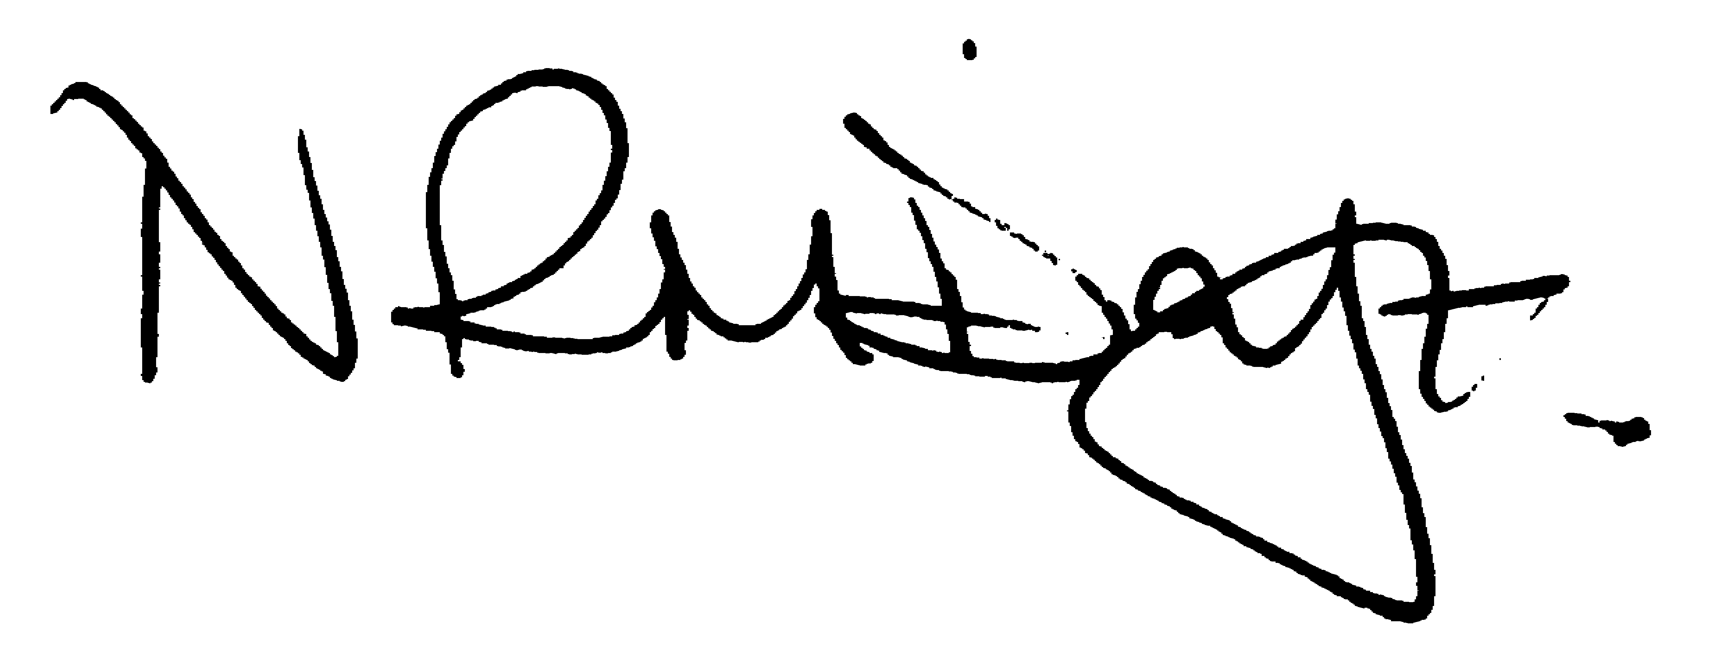

Nikki Daft – Parish Clerk

AGENDA

APOLOGIES AND ACCEPTANCE OF APOLOGIES

19/18 PUBLIC QUESTIONS AND/COMMENTS

Public participation may continue until for 15 minutes after which the public must not take part at any other time during the meeting. Any member of the public can make a recording of any part of the meeting. All audible sounds to be switched to silent unless otherwise agreed at the start of the meeting.

POLICE REPORT AND NCC UPDATE

To receive a verbal report from the Police and NCC representative if in attendance

19/19 NOTIFICATION OF ANY DISCLOSABLE PECUNIARY INTERESTS OR OTHER INTERESTS
Only in respect of matters which are to be considered by members below. (Disclosures previously declared and registered need not be repeated).

- To receive declarations of interest
- Councillors to declare any personal interest in any items on the agenda
- Councillors to declare any personal and/or prejudicial interest in any items on the agenda and to inform the Chairman if they wish to speak on the matter during public participation

19/20 MINUTES - To approve the minutes of the meetings held on 22nd May 2019 as a true record.

19/21 RESOLUTIONS AND ACTIONS - MATTERS FROM PREVIOUS MINUTES

- Cemetery – weed spray gravel, remove/mulch tree branches
- Notice board – Little Irchester
- Skate park repairs
- Fair

19/22 FINANCIAL/POLICIES

- To Approve Payments for June 2019 details sent to councillors via email (Clerk)
- To receive information regarding the current financial statement – reconciliation statement sent to councillors via email (Clerk)
- To agree the authorisation of the bacs payments

19/23 RECREATION GROUNDS

- To receive and agree the reports/repairs/damage to the recreation grounds (JD)

19/24 HIGHWAYS

- To agree any items that need to be added to the next agenda
- To discuss the problem with parking at the junction of Townwell Lane as the refuse lorry cannot access the road and the safety at the junction
- To discuss the flytipping issues within the village and determine what course of action the pc can taker to try and resolve it (MM)
- To discuss NCC speed cameras (RE)

19/25 LITTLE IRCHESTER/KNUSTON - To agree the Highway Warden report. Matters arising will be added to the next agenda.

- To discuss the quotation for the notice board replacement

19/26 CEMETERY/WAR MEMORIAL/GARDENS

- To note the information from the Cemetery Working Party and decide if any item needs to be added to the next agenda

19/27 PLANNING

- Application No. WP/19/00316/FUL Proposal: Bounday fence and gate with a combined height of 2m - retrospective application Location: 54 High Street, Irchester, Wellingborough, Northamptonshire, NN29 7AB
- Application No. WP/19/00334/FUL Proposal: Construction of a new two storey side extension, re-design of internal layout and alterations to porch including a lean-to roof - re-submission. Location: 146 Arkwright Road, Irchester, Wellingborough, Northamptonshire, NN29 7HG

19/28 COMMUNITY/CONSULTATIONS EVENTS

- To discuss the issues regarding the current closure of the Post Office
- To discuss the request for funding in order to set up a Parkrun at Irchester Country Park (MM)
- To receive a information from the Village Voice Working Party and decide if any item needs to be added to the next agenda
- To receive information from the Parsons Hall working party
- To discuss and decide if the draft business and budget plan required by Northants County Council, in respect to Irchester having a Community Managed Library, is acceptable by the parish council in order for it to be submitted to them by 30th June 2019

19/29 CORRESPONDENCE To consider information received from incoming correspondence and decide on agenda items for the next meeting.

- Councillors email addresses
- NCALC AGM 5th October 2019

