
The Parish Council of Irchester
Clerk  Nikki Daft PSLCC  45 Park Road  Irthlingborough  Northants  NN9 5PW |  | Telephone 01933 384180  irchesterpc@gmail.com  www.hugofox.com/community/irchester-parish-council-13388/about-us

Dear Councillor June 2020

You are hereby summoned to attend the virtual meeting of Irchester Parish on Wednesday 24th June 2020 at 7.15p.m.via Zoom

Yours faithfully
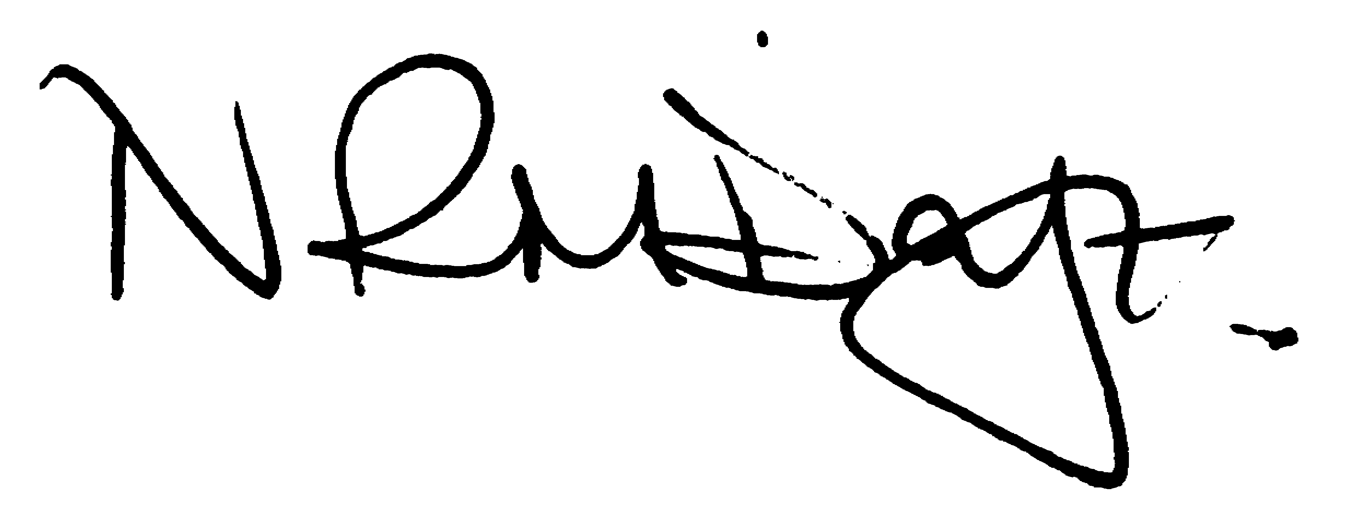

Nikki Daft – Parish Clerk

AGENDA

APOLOGIES AND ACCEPTANCE OF APOLOGIES

20/10 PUBLIC QUESTIONS, POLICE REPORT AND NCC UPDATE

Public to send questions to council prior to the meeting due to time constraints

20/11 NOTIFICATION OF ANY DISCLOSABLE PECUNIARY INTERESTS OR OTHER INTERESTS
Only in respect of matters which are to be considered by members below. (Disclosures previously declared and registered need not be repeated).

- To receive declarations of interest
- Councillors to declare any personal interest in any items on the agenda
- Councillors to declare any personal and/or prejudicial interest in any items on the agenda and to inform the Chairman if they wish to speak on the matter during public participation

20/12 MINUTES

a) To approve the minutes of the virtual meeting held on 20th May 2020 as a true record ..\mins 2021\may2020mins.doc

20/13 FINANCIAL/POLICIES

- To Approve Payments for June 2020 (Clerk)
- To receive information regarding the current financial statement (Clerk)
- To agree the authorisation of the bacs payments
- To receive recommendations from the Finance working party
- To adopt the Standing Orders, Financial Regulations and Financial Risk Assessment
- To transfer the £6,000 from the Election budget - £5k to Community Projects and £1k to seat replacement
- Consider financial support for the Community Managed buildings
- Consider the draft application for Community Building Grant

20/14 CEMETERY/WAR MEMORIAL

- To discuss adding a shelter to the cemetery grounds and look at the possible position and cost.
- To discuss the possibility of having a tablet installed over two cremated remains plots.
- To discuss the repair of the post to the cemetery gates.

20/15 PLANNING

To discuss any planning issues

- WP/20/00295/FUL Proposal: Phase 1 of the proposed development is the construction of a floating landing stage and canoe portage capable of accommodating waterbourne traffic to Chester House Farm. A temporary construction of a site compound and launch site 2 miles downstream from which all materials, plant and personnel will access the construction site. Phase 2 proposes construction of a permanent footpath to the site on the River Nene from Chester House Farm for use by visitors accessing the site by boat/canoe. Access during construction of Phase 2 will be from the A45. A site compound will be located in the car park of Chester House Farm for the duration of Phase 2. Location: Chester House No 1, Higham Road, Irchester, Wellingborough, Northamptonshire, NN29 7EZ
- WP/20/00316/FUL Proposal: Demolition of the existing rear single storey sections, build a rear part two storey part ground floor extension, replacement of the old wooden windows, Internal re-works, overall renovation and the addition of two parking spaces to the rear of the property - re-submission Location: 124 Station Road, Irchester,

20/16 HIGHWAYS

To receive information regarding any highways issues

- To discuss the cost of replacing the bus shelter along Gipsy Lane
- To discuss the cost of replacing the broken seat near Knuston bridge with a recycled one
- To discuss the request for yellow lines and bollards along Farndish Road opposite the war memorial
- To discuss the progress with the trimming of the trees in Farndish Road, Wollaston Road and London Road Little Irchester
- To discuss replacing the plastic bollards with wooden bollards to the make shift layby along London Road.

20/17 CORRESPONDENCE

To consider information received from incoming correspondence and decide on agenda items for the next meeting.

- To discuss the request for football training to commence using the recreation ground

