IRCHESTER PARISH COUNCIL

Minutes of the Ordinary Meeting of the Parish Council held on Wednesday 31st January 2024 at the Village Hall, School Road at 7.15p.m.

Members Present:
P Armstrong – In the Chair

Councillors
L Brown JP Carr A Hurley S East D Shroll K Watts M May

The meeting started at 7.15pm. There were 2 members of the public present & NNC Cllr T Partridge-Underwood

Apologies - Received by the Clerk which were Agreed and Accepted from Cllrs J Dunkley, T Maguire, P Smith & B Leeson. Cllr K Clark did not attend the meeting or give apologies

23/71 Public Questions, Police Report and NNC Update
Public - Query re the location of the ‘old section’ of the cemetery and if the memorial testing policy had changed which was answered by the Clerk.

NNC – Cllrs JP Carr & T Partridge-Underwood met with NNC Highways Executive Member Matt Binley regarding highways issues within the village. Issues included - parking in Farndish Road, alleyways, drains, block paving, trees near crossing & weed spraying of which a response from highways is awaited. The temporary mortuary, which was set up during covid, is being used for training by the fire and police when not in use. There currently seems to be an issue with potent drugs so local magazines are being asked to advertise the warning bulletin released.

Query re NNC budgets regarding debts and will they be passed on to residents. It was stated that NNC are trying not to overspend in certain areas however social care and children remain a priority.

Cllr TPU let the meeting

Police – report sent to councillors

23/72 Notification of Any Interests

None declared

23/73 Minutes

RESOLVED - The minutes from 29th November 2023 meeting were agreed as a true record and signed by the Chair.

23/74 Financial Matters

- Payments – RESOLVED: That the payments for £10,830.87 for December 2023 and £5180.09 for January 2024 were approved. Directs Debit payments for January Hugo fox and N Power

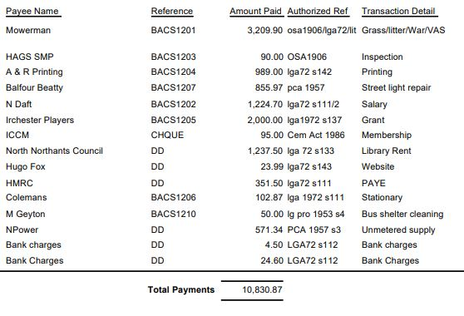

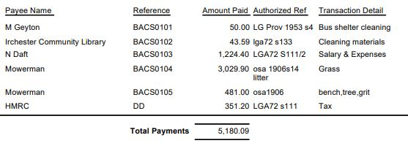

- The Current financial statement after the payments being £199,492.32
- RESOLVED that Cllrs JP Carr & L Brown to authorise the bacs payments for January 2024

23/75 Cemetery/War Memorial

- It was stated that few interments had taken place throughout December and January. A tree had fallen down in the winds across the fence at the top of the cemetery where damage had been caused to the wire fencing. This has now been removed and the fence has been reinforced with a wooden post.
- A quotation of £1950 had been received to repair and gravel some graves in the old section of the cemetery where there were no longer lessees able to do so. It was RESOLVED to accept this quotation and carry out the appropriate repairs
- It was noted that 4 graves need to be levelled and reseeded.
- RESOLVED to adopt the Memorial Testing Policy for 2024. It was stated that a notice would be placed in the next 2 editions of the village magazine, on the cemetery notice board and the testing would take place October/November 2024

23/76 Highways

- It was stated that there was a damaged drain in Milton Road Little Irchester that has been reported to fixmystreet
- Highways had sent a list through of the alleyways that they were responsible for maintaining however there were queries on 4 of them which needed further investigation.
- Representatives for the working party for the Wellingborough, Wollaston and Irchester cycleway were agreed as Cllr M May & K Watts
- Discussion took place regarding the 40mph reduction near to the Country Park and it was agreed to accept NNC proposals but ask if the new speed limit could extend past the extrance to the new solar farm.
- Discussion took place regarding the parking restrictions for Farndish Road Irchester and Daniels Road Little Irchester and it was agreed to accept NNC proposals.

23/77 Play Areas

- HAGS had been contacted regarding the inspection of the skate park however they have now stated that they no longer install skateparks or carry out repairs. A complaint has been sent to them asking why the pc were not informed of this prior to the inspection. Since the complaint was sent they have now issued a quotation for repairs. A second quotation had also been received and it was RESOLVED to accept the quotation of £2714.29 plus VAT from Kompan.

23/78 Planning
- NW/23/00763/FUL - Proposed New Vehicular Access Crossing onto B569 Wollaston Road, hardstanding, the removal of part of an existing hedgerow and replacement hedgerow Location: 132 Wollaston Road Irchester Wellingborough NN29 7DH - No issues
- NW/23/00812/FUL – Single storey rear, side and front extensions including 2 bedrooms – 33 Knuston Spinney Irchester – No issues

23/79 Community Buildings
Cllr JP Carr left the meeting

Library - Several quotations for the cleaning of the windows for the Community Library had been received however Councillors felt all were quite high. A further company was recommended for quotation so this item was deferred to the next meeting.

Cllr Carr returned to the meeting.

Youth Centre – A meeting was held with council representatives and the YCT committee. It was stated that there seemed to be some confusion over some wording in the lease so Council asked the Clerk to write to the YCT asking for a copy of the lease that they are working from. This item was deferred until further information had been received.

23/80 Correspondence
- Four complaints had been received regarding the block paving which becomes slippery during wet and icy weather. NNC had been contacted but stated they would not grit the footpath or remove the block paving. Complainants were advised of the pcs gritting programme and NNC responses. This issue was also discussed with the NNC Executive Member for highways.
- A complaint had been received regarding the dog bin at Woodlands where dog walkers were leaving poo bags on the floor and not using the bin correctly when the bin was full. It was agreed to monitor the situation and add this to the April agenda.

23/81 Exclusive to Public and Press

RESOLVED: That pursuant to the Public Bodies (Admission to Meetings) Act 1960, the public and press is excluded from the meeting for the item of business on the grounds that publicity would be prejudicial to the public interest by reason of the confidential nature of the business to be discussed.

23/82 Promotion Agreement Austin Close

The Council agreed recommendations for the promotion agreement were sent to the promoters agent however the promoter did not agree with most of them. Awaiting a further update.

Meeting closed at 8.20 pm

Chair

These minutes are draft until agreed at the next full council meeting

