
The Parish Council of Irchester
Clerk  Nikki Daft PSLCC  45 Park Road  Irthlingborough  Northants  NN9 5PW |  | Telephone 07525 909528  irchesterpc@gmail.com

Dear Councillor 17th February 2020

You are hereby summoned to attend the Ordinary meeting of Irchester Parish Council to be held in the Village Hall, School Road Irchester on Wednesday 26th February 2020 at 7.15p.m.

Yours faithfully
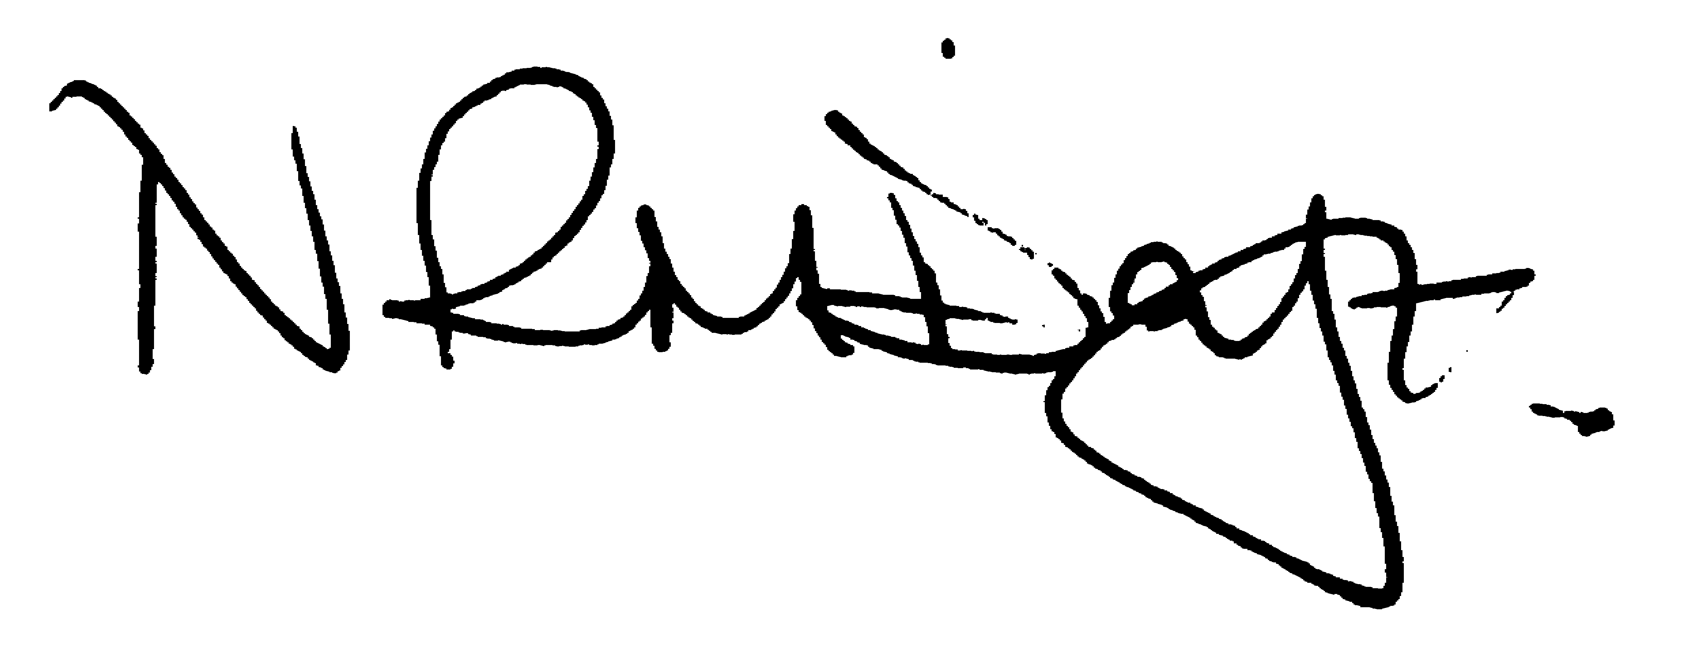

Nikki Daft – Parish Clerk

Visit from Crown Estates regarding public consultation for the Land to the West of Rushden Lakes (20minutes)

AGENDA

APOLOGIES AND ACCEPTANCE OF APOLOGIES

19/94 PUBLIC QUESTIONS AND/COMMENTS

Public participation may continue until for 15 minutes after which the public must not take part at any other time during the meeting. Any member of the public can make a recording of any part of the meeting. All audible sounds to be switched to silent unless otherwise agreed at the start of the meeting.

POLICE REPORT AND NCC UPDATE

To receive a verbal report from the Police and NCC representative if in attendance

19/95 NOTIFICATION OF ANY DISCLOSABLE PECUNIARY INTERESTS OR OTHER INTERESTS
Only in respect of matters which are to be considered by members below. (Disclosures previously declared and registered need not be repeated).

- To receive declarations of interest
- Councillors to declare any personal interest in any items on the agenda
- Councillors to declare any personal and/or prejudicial interest in any items on the agenda and to inform the Chairman if they wish to speak on the matter during public participation

19/96 MINUTES - To approve the minutes of the meetings held on 29th January 2020 as a true record.

19/97 RESOLUTIONS AND ACTIONS - MATTERS FROM PREVIOUS MINUTES

- Agree Section 136 Grass mowing - confirmed
- Temporary repair to play equipment on Recreation Ground – completed
- NHW letter – sent
- Planning responses sent with request for site visit
- Circus – letter sent
- Village Voice – tax increase explanation sent
- Highways – pot holes information requested

19/98 FINANCIAL/POLICIES

- To Approve Payments for February 2020 details sent to councillors via email (Clerk)
- To receive information regarding the current financial statement – reconciliation statement sent to councillors via email (Clerk)
- To agree the authorisation of the bacs payments

19/99 RECREATION GROUNDS

- To receive and agree the reports/repairs/damage to the recreation grounds (JD)
- To discuss the concerns by residents regarding the horse and cart using the recreation ground.
- To discuss the condition of the exercise equipment on the Recreation Ground and decide if they need to be removed, replaced or left insitu.

19/100 HIGHWAYS

- To agree any items that need to be added to the next agenda
- To consider the quotation to replace the panes in the bus shelter on the corner of Gipsy Lane

19/101 LITTLE IRCHESTER/KNUSTON - To agree the Highway Warden report. Matters arising will be added to the next agenda.

19/102 CEMETERY/WAR MEMORIAL/GARDENS

To discuss if the council wish to repair the headstones in the cemetery that have been highlighted as unsafe and where no one has taken responsibility for them. Cost of repair would be £144.00 without ground anchors and £65.00 with ground anchors plus VAT.

19/103 PLANNING

- WP/20/00044/FUL Proposal: First floor extension above existing garage. Location: 10 Cedar Close, Irchester,
- WP/20/00035/FUL Proposal: Demolition of existing garage, part two storey and part single storey side extension. Location: 6 Redwood Close, Irchester
- WP/20/00050/FUL Proposal: Demolition of existing conservatory. Single storey rear extension. Location: 7 Cedar Close, Irchester
- WP/20/00009/FUL Proposal: Retrospective application to replace an existing boundary which consists of a 1.8m fence / 0.6m wall and approx 4.5m Conifer trees with 1.75m pillars, a 0.6m wall and a 0.9m arched fence on top of the wall between the pillars. Location: 74 Farndish Road, Irchester
- WP/20/00057/FUL Proposal: Proposed new dwelling including access, parking & amenity space & demolition of existing garage and replacement garage within the curtilage of a listed building. Location: 1A London End, Irchester
- WP/20/00058/LBC Proposal: Listed building consent for the demolition of existing garage to allow for the development of a proposed new dwelling including access, parking & amenity space and replacement garage within the curtilage of a listed building. Location: 1A London End, Irchester
- WP/19/00670/FUL Proposal: Proposed conversion of A2 office to 4no. apartment dwellings Class C3 including the provision of refuse and cycle storage in an enclosed rear courtyard and the landscaping of rear courtyard/garden Location: 52 High Street, Irchester – site visit

19/104 COMMUNITY/CONSULTATIONS EVENTS

- To discuss if the Council or other organisations are commemorating VE Day and what support can be given.

19/105 CORRESPONDENCE To consider information received from incoming correspondence and decide on agenda items for the next meeting.

- Request for dog bin Gipsy Lane (near to the village sign)

19/106 EXCLUSIVE TO PUBLIC AND PRESS

Library – update regarding the progress with the library

