
The Parish Council of Irchester
Clerk  Nikki Daft MILCM  45 Park Road  Irthlingborough  Northants  NN9 5PW |  | Telephone 01933384180  Parishclerk123@gmail.com

Dear Councillor 16th January 2017

You are hereby summoned to attend the Ordinary meeting of Irchester Parish Council to be held in the Village Hall, School Road Irchester on Wednesday 25th January 2017 at 7.15p.m.

Yours faithfully
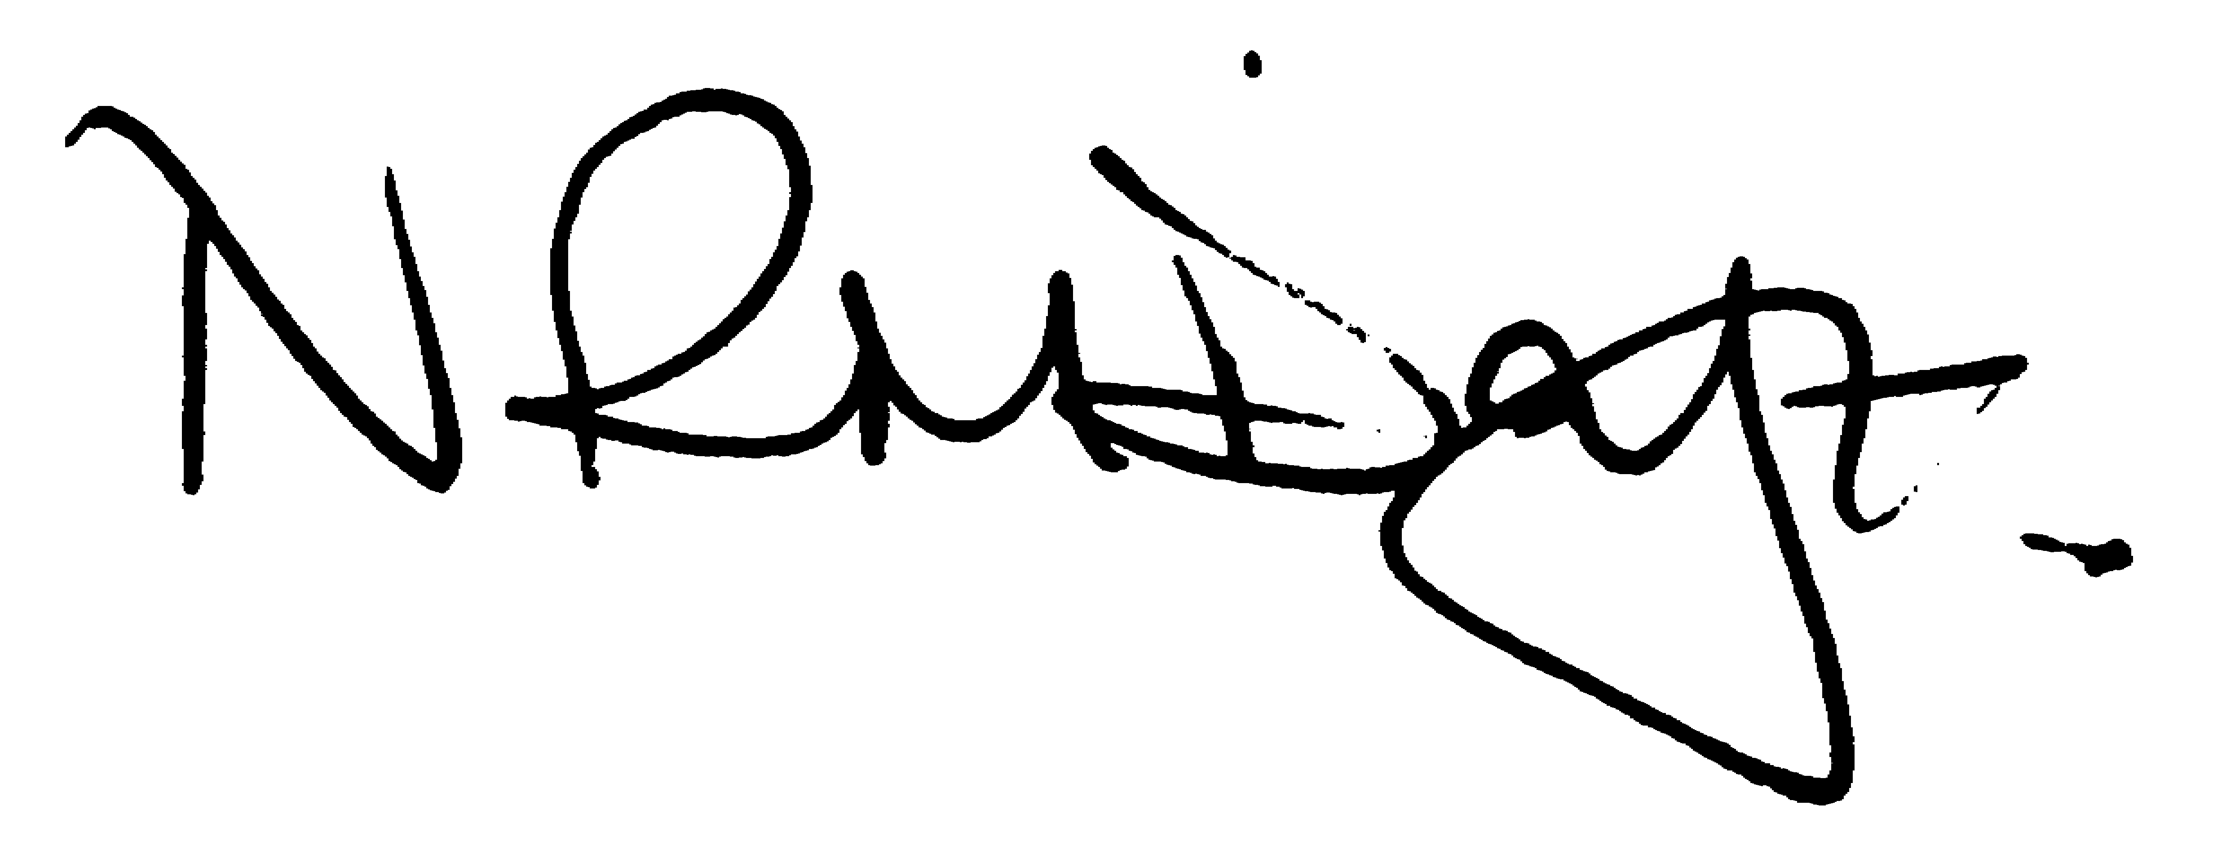

Nikki Daft – Parish Clerk

AGENDA

APOLOGIES AND ACCEPTANCE OF APOLOGIES

16/88 NOTIFICATION OF ANY DISCLOSABLE PECUNIARY INTERESTS OR OTHER INTERESTS
Only in respect of matters which are to be considered by members below. (Disclosures previously declared and registered need not be repeated).

16/89 PUBLIC QUESTIONS, POLICE REPORT AND NCC UPDATE

Public participation may continue until for 15 minutes after which the public must not take part at any other time during the meeting. Request should be made to the Chair if any member of the public wishes to make a recording of any part of the meeting. All audible sounds to be switched to silent unless otherwise agreed at the start of the meeting. A report only can also be given by the Police and NCC representatives

16/90 MINUTES - To approve the minutes of the meetings held on 30th November 2016 as a true record

16/91 RESOLUTIONS AND ACTIONS - MATTERS FROM PREVIOUS MINUTES

- Write to British Legion – completed
- Book Mayor for Remembrance Service 2017 – initial contact
- Sent F Webber email re cherry trees to cllrs – completed
- Sent annual playground report to cllrs – completed
- Confirmed contractors for 2017
- Letter sent to MP/Post Office re post box – awaiting outcome
- Obtain quotations for new village sign – ongoing
- London Road ditch land registry – JPC
- Letter Orbit re cycle sheds – completed
- Planning response – completed
- Notice for cemetery – Registrar
- BCW Recycling letter - completed

16/92 FINANCIAL/POLICIES

- To Approve Payments for December 2016 and January 2017 (Clerk)
- To receive information regarding the current financial statement (Clerk)
- To agree the authorisation of the bacs payments
- To discuss the 3 year Business Plan

16/93 RECREATION GROUNDS

- To receive and agree the reports/repairs/damage to the recreation grounds (JD)
- To receive information regarding the spares required from the annual inspection report that the lengthsman can complete

16/94 HIGHWAYS

- To agree any items that need to be added to the next agenda
- Street Doctor responses
846433 – request for conifer trees to be cut back blocking the footpath at the corner of Evelyn & Arkwright Road – NCC sent letter to owner – work completed
846438 – request to clear Alfred Street alleyway – NCC referred to Wellingborough Homes – works completed
850629 – potholes in Wollaston Road – work to be completed within next 4 months
- To receive an update re applying for a definitive footpath.
- To discuss the replacement Irchester village sign
- To discuss the grass mowing agreement from Northants County Council.
- To discuss work that can be carried out by NCC Enhancement Gang.
- To receive information from the Vehicle Activated Speed Signs

16/95 LITTLE IRCHESTER/KNUSTON - To agree the Highway Warden report, previously circulated. Matters arising will be added to the next agenda

- To receive an update regarding the closing of the Chapel and community room in Little Irchester
- To receive an update on the ownership of the ditch in London Road which needs to be cleared to avoid flooding

16/96 PLANNING

WP/16/00736/FUL – Conversion of outbuilding – 16 School Hill

16/97 NEIGHBOURHOOD PLAN - To receive an update on the progress of the NHP

16/98 CEMETERY/WAR MEMORIAL

- To receive the Registrars report and decide if details should be added to the next agenda
- To discuss the issue with soil/spoil being added to graves and grass areas from an unknown source and how to resolve a complaint regarding this.

16/99 COMMUNITY ISSUES

- To receive an update regarding lighting the alleyway in School Road
- To discuss the production of the Village Voice magazine
- To discuss the application for the Best Village Competition for 2017

16/100 CORRESPONDENCE To consider information received from incoming correspondence and decide on agenda items for the next meeting.

