
The Parish Council of Irchester
Clerk  Nikki Daft PSLCC  45 Park Road  Irthlingborough  Northants  NN9 5PW |  | Telephone 01933 384180  irchesterpc@gmail.com  www.hugofox.com/community/irchester-parish-council-13388/about-us

Dear Councillor 19th April 2021

You are hereby summoned to attend the virtual meeting of Irchester Parish on Wednesday 28th April 2021 at 7.15p.m.via Zoom

Time: Apr 28, 2021 07:15 PM London
Join Zoom Meeting
https://us02web.zoom.us/j/88282596415?pwd=RUlZZU9XY2U5aWxMUnVzRDlsRDFZdz09
Meeting ID: 882 8259 6415
Passcode: 400345

Yours faithfully
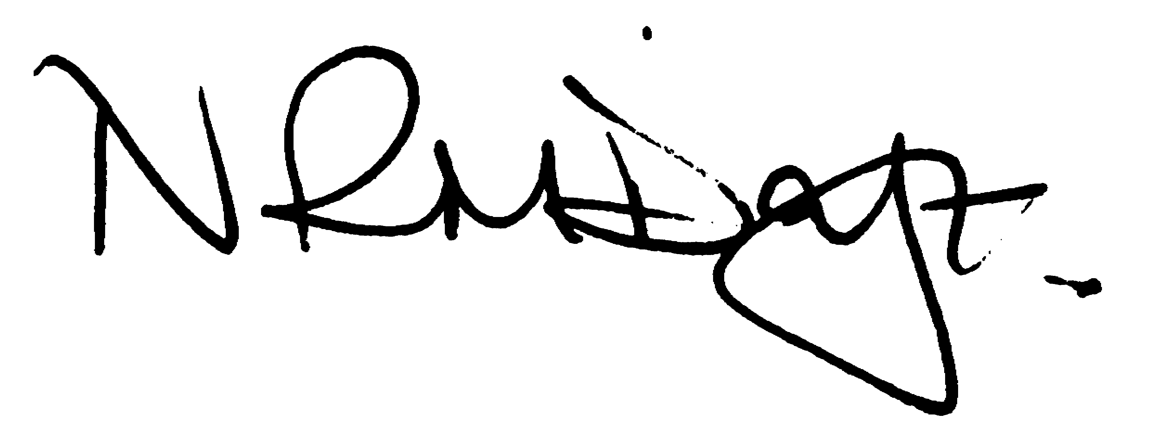

Nikki Daft – Parish Clerk

AGENDA

APOLOGIES AND ACCEPTANCE OF APOLOGIES

20/96 PUBLIC QUESTIONS, POLICE REPORT AND NNU UPDATE

Public to send questions to council prior to the meeting due to time constraints

20/97 NOTIFICATION OF ANY DISCLOSABLE PECUNIARY INTERESTS OR OTHER INTERESTS
Only in respect of matters which are to be considered by members below. (Disclosures previously declared and registered need not be repeated).

- To receive declarations of interest
- Councillors to declare any personal interest in any items on the agenda
- Councillors to declare any personal and/or prejudicial interest in any items on the agenda and to inform the Chairman if they wish to speak on the matter during public participation

20/98 MINUTES

a) To approve the minutes of the virtual meeting held on 31st March 2021 as a true record.

20/99 FINANCIAL/POLICIES

- To Approve Payments for April 2021 (Clerk)
- To receive information regarding the current financial statement (Clerk)
- To agree the authorisation of the bacs payments
- To discuss the renewal premium for the councils insurance
- To agree the Annual Governance for the External Auditor and receive the Internal Auditors Report for the accounts ending 2020/21
- To approve AGAR section 1
- To approve AGAR section 2
- To review the Standing Orders, Financial Regulations and Financial Risk Assessment.
- To discuss draft face to face meeting policy

20/100 CEMETERY/WAR MEMORIAL

- To receive an update on cemetery matters
- To discuss the possibility of having a seat donated for the cemetery, what type and where to position one.

20/101 PLANNING

- NW/21/00306/FUL – 1st Floor side extension – 48 Woodlands Road
- NW/21/00314/FUL – Extension of existing drop kerb – 34 Station Road

20/102 HIGHWAYS

To receive information regarding any highways issues

20/103 PLAY AREAS

- To receive quotations for replacement play equipment of the seesaw in Little Irchester.
- To discuss the engineers visit from Wicksteed and the lead time mentioned.

20/104 COMMUNITY INFORMATION

To discuss the possibility of Wilding and Nature conservation within the village. (RE)

20/105 CORRESPONDENCE

To consider information received from incoming correspondence and decide on agenda items for the next meeting.
- Request from WI to have knitted/crocheted poppies for the War Memorial for the Remembrance Day Service
- Details from RBLI regarding purchasing of Unknown Tommy
- Request from Crimewave Security Consultancy to attend a pc meeting

20/106 EXCLUSIVE TO PUBLIC AND PRESS

20/107 COMMUNITY GRANT

To discuss the request for grant funding from Irchester Youth Center Parsons Hall

20/108 CLERK HOLIDAY

To discuss unused holiday from 20/21

