
The Parish Council of Irchester
Clerk  Nikki Daft PSLCC  45 Park Road  Irthlingborough  Northants  NN9 5PW |  | Telephone 01933 384180  irchesterpc@gmail.com  www.hugofox.com/community/irchester-parish-council-13388/about-us

Dear Councillor 11th May 2020

You are hereby summoned to attend the virtuall meeting of Irchester Parish on Wednesday 20th May 2020 at 7.15p.m.via Zoom

Yours faithfully
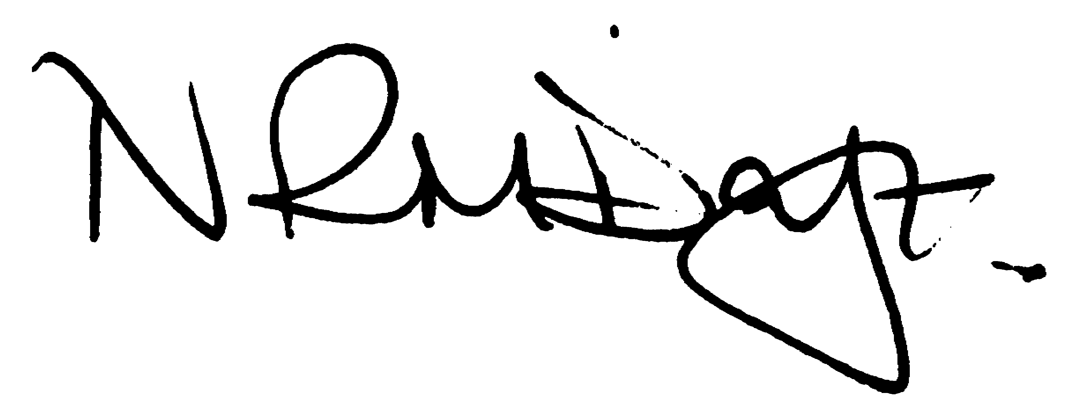

Nikki Daft – Parish Clerk

AGENDA

APOLOGIES AND ACCEPTANCE OF APOLOGIES

20/01 PUBLIC QUESTIONS, POLICE REPORT AND NCC UPDATE

Public to send questions to council prior to the meeting due to time constraints

20/02 NOTIFICATION OF ANY DISCLOSABLE PECUNIARY INTERESTS OR OTHER INTERESTS
Only in respect of matters which are to be considered by members below. (Disclosures previously declared and registered need not be repeated).

- To receive declarations of interest
- Councillors to declare any personal interest in any items on the agenda
- Councillors to declare any personal and/or prejudicial interest in any items on the agenda and to inform the Chairman if they wish to speak on the matter during public participation

20/03 MINUTES

a) To approve the minutes of the virtual meeting held on 29th April 2019 as a true record

20/04 FINANCIAL/POLICIES

- To Approve Payments for May 2020 (Clerk)
- To receive information regarding the current financial statement (Clerk)
- To agree the authorisation of the bacs payments
- To discuss setting up a subscription for Zoom for the following year
- To agree the Annual Governance for the External Auditor and receive the Internal Auditors Report for the accounts ending 2019/20
- To approve AGAR section 1
- To approve AGAR section 2

20/05 ACCEPTANCE OF OFFICERS/WORKING PARTIES & RESPRESENATIVES

To Agree the Officers, Working parties and representatives for 2020/21

20/06 DATES OF COUNCIL MEETINGS 2019/20

24th June 2020 26th August 2020
30th September 2020 28th October 2020
25th November 2020 27th January 2021
24th February 2021 31st March 2021
28th April 2021 19th May 2021 (election year)

20/07 CEMETERY/WAR MEMORIAL

- To discuss adding a shelter to the cemetery grounds

20/08 HIGHWAYS

To receive information regarding any highways issues

- To discuss replacing the bus shelter along Gipsy Lane

20/09 CORRESPONDENCE

To consider information received from incoming correspondence and decide on agenda items for the next meeting.

