
The Parish Council of Irchester
Clerk  Nikki Daft  45 Park Road  Irthlingborough  Northants  NN9 5PW |  | Telephone 07525909528  irchesterpc@gmail.com  www.hugofox.com/community/irchester-parish-council-13388/about-us

Dear Councillor 16th September 2024

You are hereby summoned to attend the Ordinary meeting of the Parish Council to be held at Village Hall, School Lane, Irchester on Wednesday 25th September 2024 at 7.15p.m.

Yours faithfully
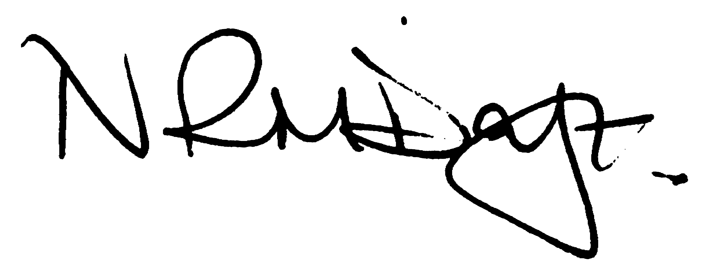

Nikki Daft – Parish Clerk

AGENDA

APOLOGIES AND ACCEPTANCE OF APOLOGIES

24/40 NOTIFICATION OF ANY DISCLOSABLE PECUNIARY INTERESTS OR OTHER INTERESTS
Only in respect of matters which are to be considered by members below. (Disclosures previously declared and registered need not be repeated).

- To receive declarations of interest
- Councillors to declare any personal interest in any items on the agenda
- Councillors to declare any personal and/or prejudicial interest in any items on the agenda and to inform the Chairman if they wish to speak on the matter during public participation

24/41 PUBLIC QUESTIONS, POLICE REPORT AND NCC UPDATE

Public participation may continue until for 15 minutes after which the public must not take part at any other time during the meeting. Request should be made to the Chair if any member of the public wishes to make a recording of any part of the meeting. All audible sounds to be switched to silent unless otherwise agreed at the start of the meeting. A report only can also be given by the Police and NCC representatives

24/42 MINUTES

- To approve the minutes of the meeting held on 28th August 2024 as a true record

24/43 FINANCIAL/POLICIES

- To Approve Payments for September 2024 (RFO)
- To receive information regarding the current financial statement (RFO)
- To agree the authorisation of the bacs payments
- To discuss applying for a Unity Trust Multi Pay Card
- To receive details of the quarterly budget

24/44 RECREATION GROUNDS

- To receive an update regarding the recreation facilities
- To discuss the cost of a restricted lock and alternative methods for the recreation ground gate
- To discuss the quotation for the tree survey for the Rec & other areas
- To discuss cost for a trophy cup for the late Cllr Maguire
- To discuss unwanted activity on the recreation ground and resolutions to the problem.

24/45 HIGHWAYS

- To determine highways issues to be added to the next agenda
- To receive an update regarding the siting of a memorial bench (AH)
- To discuss issues with the VAS signs and if a replacement is required.

24/46 CEMETERY/WAR MEMORIAL

- To receive information regarding the cemetery
- To discuss letter received regarding access to the cemetery from private land
- To receive an update regarding the Remembrance Day Service
- To decide if you would like both War Memorials decorated with poppies as previous years from the WI.

24/47 PLANNING

- NW/24/00431/FUL Proposal: Double dropped kerb for vehicular access to property and
creation of hardstanding to front of property. Location: 31 London Road Little Irchester
- NW/24/00331/FUL Proposal Partial change of use Class 3 to dog grooming salon – updated plans 10 School Hill Irchester
- NW/24/00470/FUL – Conversion of stable, addition of first floor & single storey extension – 15 Thrift Street, Irchester

24/48 CORRESPONDENCE

To consider information received from incoming correspondence and decide on agenda items for the next meeting.

24/49 EXCLUSIVE TO PUBLIC AND PRESS

To agree to discuss the following item exclusive to public and press

24/50 AUSTIN CLOSE UPDATE

To receive an update regarding Austin Close

24/51 SPORTS ASSOCIATION LEASE

To receive information regarding the SA lease

