
The Parish Council of Irchester
Clerk  Nikki Daft PSLCC  45 Park Road  Irthlingborough  Northants  NN9 5PW |  | Telephone 01933 384180  irchesterpc@gmail.com  www.hugofox.com/community/irchester-parish-council-13388/about-us

Dear Councillor 17th February 2021

You are hereby summoned to attend the virtual meeting of Irchester Parish on Wednesday 24th February 2021 at 7.15p.m.via Zoom

Time: Feb 24, 2021 07:15 PM London

Join Zoom Meeting
https://us02web.zoom.us/j/86996891661?pwd=cG5kSHZwdUwrVEtpS09pbE9BWHFGQT09

Meeting ID: 869 9689 1661
Passcode: 766424
Yours faithfully
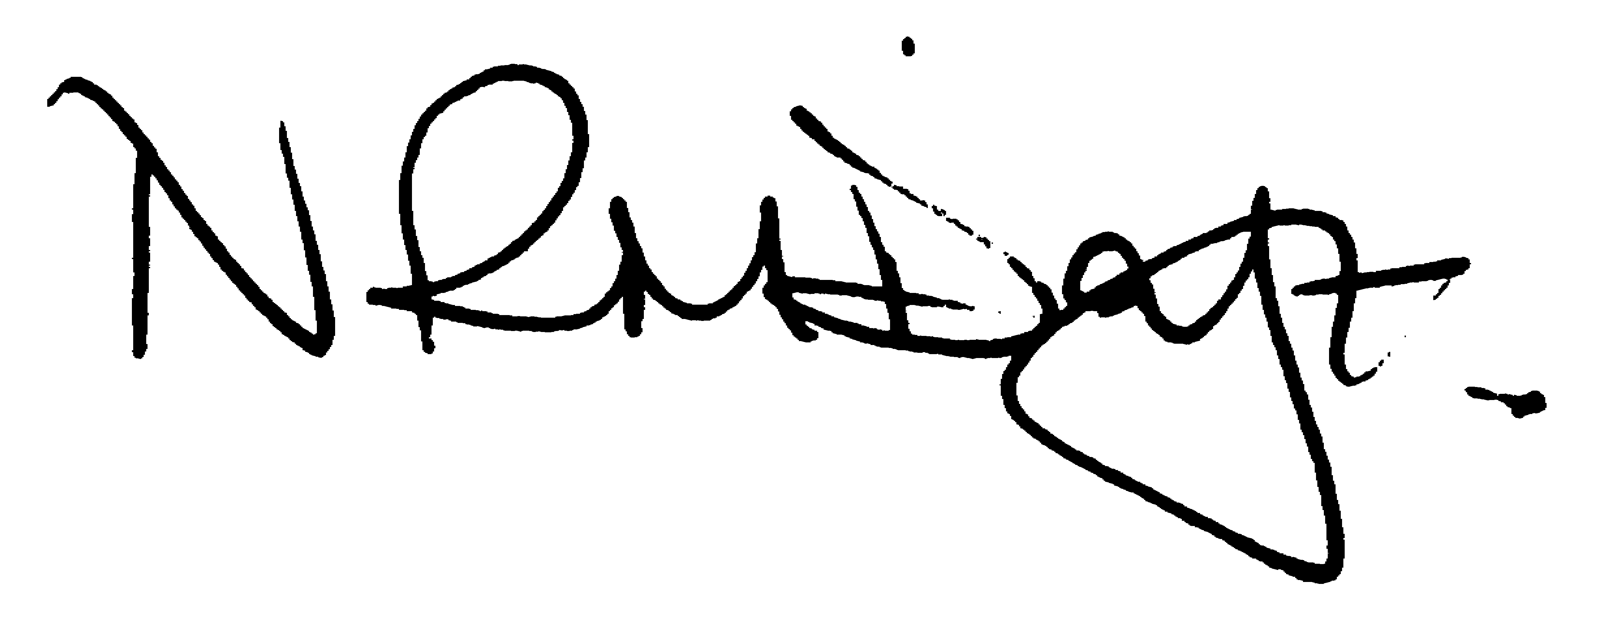

Nikki Daft – Parish Clerk

AGENDA

APOLOGIES AND ACCEPTANCE OF APOLOGIES

20/73 PUBLIC QUESTIONS, POLICE REPORT AND NCC UPDATE

Public to send questions to council prior to the meeting due to time constraints

20/74 NOTIFICATION OF ANY DISCLOSABLE PECUNIARY INTERESTS OR OTHER INTERESTS
Only in respect of matters which are to be considered by members below. (Disclosures previously declared and registered need not be repeated).

- To receive declarations of interest
- Councillors to declare any personal interest in any items on the agenda
- Councillors to declare any personal and/or prejudicial interest in any items on the agenda and to inform the Chairman if they wish to speak on the matter during public participation

20/75 MINUTES

a) To approve the minutes of the virtual meeting held on 27th January 2021 as a true record..\mins 2021\Jan2021mins.doc

20/76 FINANCIAL/POLICIES

- To Approve Payments for February 2021 (Clerk)
- To receive information regarding the current financial statement (Clerk)
- To agree the authorisation of the bacs payments

20/77 CEMETERY/WAR MEMORIAL

- To receive an update on cemetery matters

20/78 PLANNING

- NW/21/00036/FUL – Conversion of detached garage roof space to create annex and installation of dormer windows – 27 Knuston Road
- NW/21/00144/LBC - Conversion of detached garage roof space to create annex and installation of dormer windows – 27 Knuston Road

20/79 HIGHWAYS

To receive information regarding any highways issues
- To discuss the planter for the flower beds along Wollaston Road outside the old post office
- To look at the definitive Map Order of 2016 and determine if any action needs to be taken. https://www.northantscalc.com/uploads/difinitive-map-modification-order-sep16.pdf.

20/80 PLAY AREAS

- To receive quotations for replacement play equipment and discuss what type is required.
- To discuss the information received regarding the area in Denton Close

20/81 COMMUNITY INFORMATION

- To discuss the positioning and planting of free Woodland trees for the village (AM)
- Discuss the possibility of a Community Orchard
- Update on May Local Government Elections and Unitary Council for the North

20/82 CORRESPONDENCE

To consider information received from incoming correspondence and decide on agenda items for the next meeting.

