
The Parish Council of Irchester
Clerk  Nikki Daft  45 Park Road  Irthlingborough  Northants  NN9 5PW |  | Telephone 07525909528  irchesterpc@gmail.com  www.hugofox.com/community/irchester-parish-council-13388/about-us

Dear Councillor 17th June 2024

You are hereby summoned to attend the Ordinary meeting of the Parish Council to be held at Village Hall, School Lane, Irchester on Wednesday 26th June 2024 at 7.15p.m.

Yours faithfully
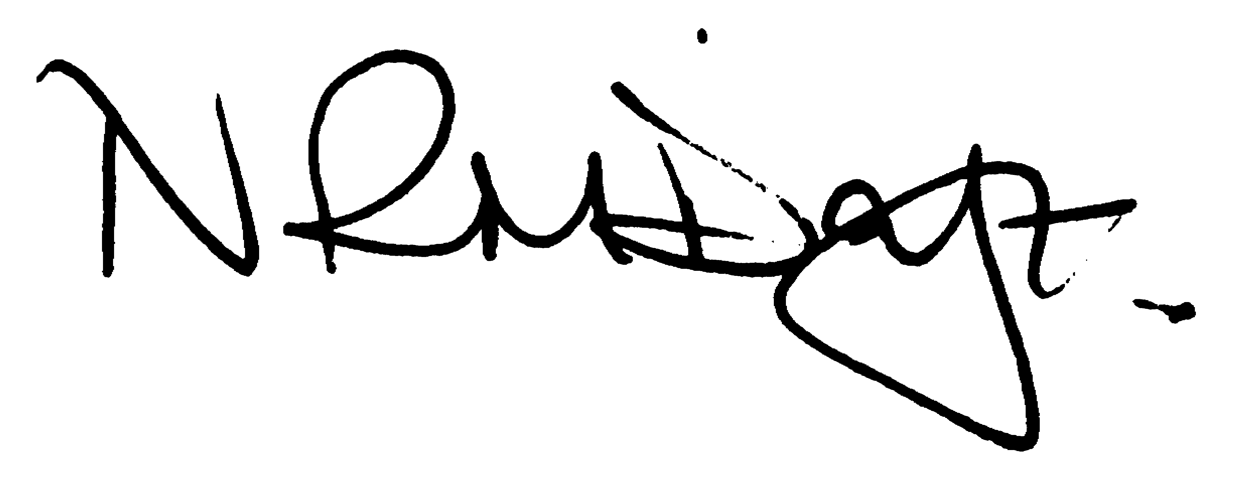

Nikki Daft – Parish Clerk

AGENDA

APOLOGIES AND ACCEPTANCE OF APOLOGIES

24/16 NOTIFICATION OF ANY DISCLOSABLE PECUNIARY INTERESTS OR OTHER INTERESTS
Only in respect of matters which are to be considered by members below. (Disclosures previously declared and registered need not be repeated).

- To receive declarations of interest
- Councillors to declare any personal interest in any items on the agenda
- Councillors to declare any personal and/or prejudicial interest in any items on the agenda and to inform the Chairman if they wish to speak on the matter during public participation

24/17 PUBLIC QUESTIONS, POLICE REPORT AND NCC UPDATE

Public participation may continue until for 15 minutes after which the public must not take part at any other time during the meeting. Request should be made to the Chair if any member of the public wishes to make a recording of any part of the meeting. All audible sounds to be switched to silent unless otherwise agreed at the start of the meeting. A report only can also be given by the Police and NCC representatives

24/18 MINUTES

- To approve the minutes of the meeting held on 29th May 2024 as a true record

24/19 CO OPTION

- To consider the co option of a new member to the council

24/20 FINANCIAL/POLICIES

- To Approve Payments for June 2024 (RFO)
- To receive information regarding the current financial statement (RFO)
- To agree the authorisation of the bacs payments
- To receive details of the quarterly budget

24/21 RECREATION GROUNDS

- To receive an update regarding the recreation facilities
- To discuss the painting of the metal fence and gate at the recreation ground (BL)
- To discuss the use of the recreation ground and key holders of the gate (BL)

24/22 HIGHWAYS

- To determine highways issues to be added to the next agenda
- To receive an update regarding the request for a memorial bench (AH)
- To discuss tribute suggestion for the late T Maguire (MM)

24/23 CEMETERY/WAR MEMORIAL

- To receive information regarding the cemetery
- To discuss volunteers weeding and helping tidy the War Memorial

24/24 PLANNING

- NW/24/00322/FUL Use of the car par at Irchester Sports and Social Club, every Saturday and Sunday from 10.00 - 17.00, for the siting of a mobile van to facilitate the selling of hot food (Sui Generis) Location: Recreation Ground Alfred Street Irchester

24/25 VILLAGE MAGAZINE

To discuss the Village Magazine (MM)

24/26 CORRESPONDENCE

To consider information received from incoming correspondence and decide on agenda items for the next meeting.
- Open Letter Kettering Energy Park

24/27 EXCLUSIVE TO PUBLIC AND PRESS

To agree to discuss the following item exclusive to public and press

24/28 STAFF

To discuss the advertisement and job description for the Clerk

