IRCHESTER PARISH COUNCIL

Minutes of the Meeting of the Parish Council held on Wednesday 24th September 2014 at Hilton Hall, Little Irchester at 7.15p.m.

Members Present:
P Armstrong – In the Chair

Councillors
I French P Smith J Dunkley K Clements
D May L Brown I Nunney C Painter

The meeting started at 7.15pm. There were 4 members of the public present.

Apologies - Resolved to receive and accept apologies from Cllrs T Maguire, R Elliott, A May, J Gibson & M May

14/44 DPI's

None Declared

14/45 Minutes

RESOLVED that the minutes of the meeting held on 27th August 2014 were agreed as a true record.

14/46 Public participation, police reports and NCC updates

The Chair stated that public participation may continue for 15 minutes after which the public must not take part at any other time during the meeting. Request should be made to the Chair if any member of the public wishes to make a recording of any part of the meeting. All audible sounds to be switched to silent unless otherwise agreed at the start of the meeting. A report only can also be given by the Police and NCC representatives

Public comments –

War Memorial bushes need to be trimmed – scheduled before November Remembrance Day.

Question was asked if the pc had received any information on the proposed solar farm. - No details had been submitted to pc on this but it was stated that the company may attend the next meeting.

Grange Way planning application – it was suggested that the proposed buildings be the same as others within the area.

Historical Society have agreed to purchase either a bench or bin for the skate park.

Irchester Surgery patient group need more members in order to continue to operate.

Chair thanked the public for their comments.

Police:

Little Irchester
Assault without injury – Offender known to victim.

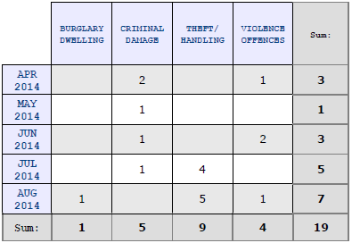

Irchester

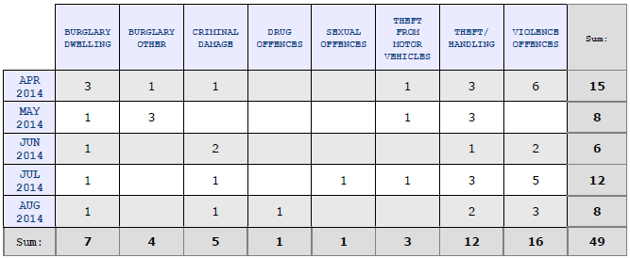
Assault without injury – DV Related
Section 5 POA
Assault with injury – DV Related

Knuston

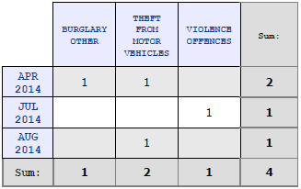

14/47 Actions/Matters from previous minutes

New Solicitor appointed CJ Spoor from Church Street, Rushden. He had received details from Wilson Browne however the information for the Bowls Club, Sports Association, Village Hall and Parsons Hall had not been included in the information. The solicitor to make a further request for missing papers.

DPPO signs received and awaiting installation

S106 meeting – it was agreed to hold a meeting next year.

Wet pore repair ordered and awaiting renewal.

14/48 Financial Matters

a) Approval of Payments – Resolved: That the payments £6457.71 for September 2014 be approved

15/09/2014 Irchester Youth Centre 300155 600.00 Grant
15/09/2014 Irchester Village Hall 300156 600.00 Grant
15/09/2014 S May 300157 65.00 Village Voice Editor
15/09/2014 Glasdon Ltd 300158 154.47 Litter bin High Street
15/09/2014 Information Commissioner 300159 35.00 Data protection
15/09/2014 Royal Mail 300160 1.28 NHP consult envelopes
15/09/2014 A & R Print 300161 999.00 Printing Village Voice/Raffle
15/09/2014 Interdirect 300162 360.00 Domain reg
15/09/2014 Arien Signs 300163 433.20 DPPO signs
15/09/2014 HM Revenue 300164 208.40 Tax & NI Sept
15/09/2014 R Annies BACS0901 470.00 Salary
15/09/2014 N Daft BACS0902 1,072.76 Salary
15/09/2014 M Wright BACS0903 69.50 Salary
15/09/2014 D Carr BACS0904 226.95 Salary
15/09/2014 JP Carr 300165 142.15 Room hire
15/09/2014 Mowerman 300166 1,020.00 Grass, Austin, Brad Alley

Total Payments 6,457.71

b) The bank statement of £154,036.43 was noted as being available after current payments made.
c) RESOLVED that Cllr Miss L Brown and I French authorise the bacs payments for September. Other council members will also find their log in details so that they can be added to the bacs authorisation list

Standing Orders suspended as PCSO C Duggan entered to the meeting

Police - Number of burglaries happening in the village where offenders were entering properties over back fences and back ways. It was suggested that residents paint fences with anti-climb paint, add carpet gripper etc. and build up low fences however notices need to be displayed if using this type of deterrent. Thefts were mainly jewellery related and to date no one had been detained.

There had been three police operations within the area where an arrest had been made and property recovered. Patrols had also increased and Woodlands Road and Gipsy Lane residents had been advised to secure buildings.

Theft from motor cars and also number plates had also been stolen. Police will issue anti-theft screws if required. Councillors asked if more foot patrols could take place however Irchester usual PCSO was currently unwell.

It was requested if the police could attend Austin Close area once the skate park commences.

The Council agreed to include police warning information in the next Village Voice and place on the web site.

Chair thanked the police for attending

Standing Orders resumed

14/49 Recreation Grounds

- Skate park - the order had been placed with HAGS and work was scheduled to start in October. Disco for Saturday 27th September had been cancelled due to lack of interest. The Grand Raffle to be drawn on 1st October at Village Hall for 7.00pm Carpenters Arms hold raffle on Sundays for the skate park and have raised £197.00 so far. On 26th October there will be a quiz evening at the Carpenters Arms with proceeds going towards the Skate Park. Once the ramps are completed then seats, bins and fencing would need to be considered. It was agreed to secure the gate at the bottom of the lane onto Austin Close Park in order to stop unauthorised vehicles entering.
- An emergency repair needed to be made to the basket ball area on the Recreation Ground in Wollaston Road at a cost of £150.00 plus VAT. RESOLVED to accept the work retrospectively.
- S106 - it was agreed to hold a meeting to discuss possible projects in 2015.
- RESOLVED to replace 3 wooden posts between the bus shelter and gate at the recreation ground and for the Clerk to order them as long as the cost is no more than £500

14/50 Highways –

a) The Highway Warden report was noted placed on the council’s website. Complaints regarding the white lines for the zebra crossing outside Co-op were still being received. Clerk to chase
b) RESOLVED to accept the quotation of £5335.20 for the change of lamps in Chester Road and to remove 6 columns.

14/51 Little Irchester/Knuston

a) The Highway Warden report was noted and placed on the council’s website. It was stated that the alleyway in Little Irchester belonged to the residents therefore it was their responsibility to clear them.

14/52 Planning - The following applications had been received:

- Neighbourhood Plan work was being undertaken in order to produce the stage 2 consultation which was scheduled to be sent out with the next Village Voice in November.
- WP/14/00600/FUL – 14 Gipsy Lane – Extension to vehicular access – No objections
- WP/14/00597/FUL – land rear of 9 Grange Way – objection regarding no parking facilities and the parking problems already in the area and that the buildings appearance should be in keeping with the other properties in the area.

14/53 Community Assets

- It was agreed to send a letter to Emotion solicitor stating that the pc were happy for the Bowls Club to under lease the roof to Emotion for a period of 25 years to allow the installed solar panels as long as the pc incurred no expense because of it.
- The parking problems at Parsons Hall were being monitored – no further action required.

14/54 Remembrance Day

Committee members were organising the event as in the previous year. Wreaths had been ordered for the parish council however organisations need to place order as soon as possible. £300 has been allocated for the order of service printing.

14/55 Correspondence

- The flood meeting was agreed for Tuesday 7th October 2014 at the Village Hall for 7pm
- A letter had been received regarding the parking of vans in Arkwright Road. NCC highways had been contacted and stated that there were no restriction for vans in residential areas. The police were informed and asked to monitor the problem as the parking was causing visibility issues.

14/46 Exclusive to public and press

14/47 Claims

Advice had been received regarding a possible insurance claim on the council. After full discussion it was agreed to adhere by the advice and suggest that the claimant contact her insurers direct. It was also agreed that the council should consider producing a volunteer’s policy for the future.

There being no further business the meeting closed at 9.20pm Chair

