
The Parish Council of Irchester
Clerk  Nikki Daft MILCM  45 Park Road  Irthlingborough  Northants  NN9 5PW |  | Telephone 01933384180  Parishclerk123@gmail.com

Dear Councillor 14th November 2016

You are hereby summoned to attend the Ordinary meeting of Irchester Parish Council to be held in the Village Hall School Road Irchester on Wednesday 30th November 2016 at 7.15p.m.

Yours faithfully
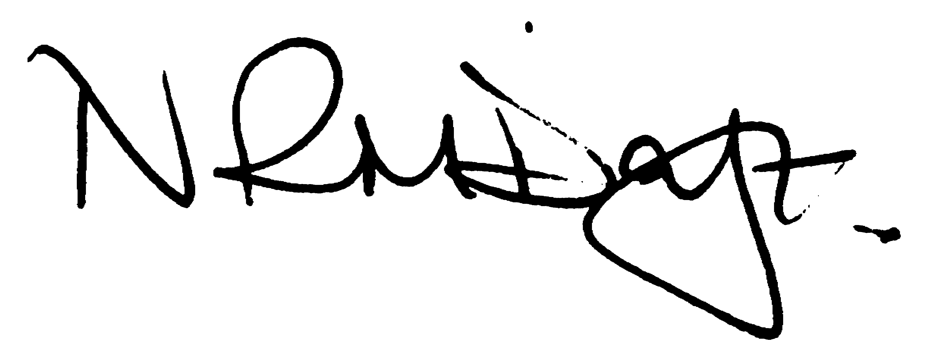

Nikki Daft – Parish Clerk

AGENDA

APOLOGIES AND ACCEPTANCE OF APOLOGIES

16/75 NOTIFICATION OF ANY DISCLOSABLE PECUNIARY INTERESTS OR OTHER INTERESTS
Only in respect of matters which are to be considered by members below. (Disclosures previously declared and registered need not be repeated).

16/76 PUBLIC QUESTIONS, POLICE REPORT AND NCC UPDATE

Public participation may continue until for 15 minutes after which the public must not take part at any other time during the meeting. Request should be made to the Chair if any member of the public wishes to make a recording of any part of the meeting. All audible sounds to be switched to silent unless otherwise agreed at the start of the meeting. A report only can also be given by the Police and NCC representatives

16/77 MINUTES - To approve the minutes of the meetings held on 26th October 2016 as true records

16/78 RESOLUTIONS AND ACTIONS - MATTERS FROM PREVIOUS MINUTES

16/79 FINANCIAL/POLICIES

- To Approve Payments for November 2016 (Clerk)
- To receive information regarding the current financial statement (Clerk)
- To agree the authorisation of the bacs payments
- To agree the budget for 2017/18 and the setting of the precept

16/80 RECREATION GROUNDS

- To receive and agree the reports/repairs/damage to the recreation grounds (JD)
- To receive details regarding the removal of the vegetation along the fence line of the recreation ground and to replant the area with shrubs
- To receive information regarding the cost of swing chains and flat bed seats for Daniels Road play area.

16/81 HIGHWAYS

- To agree any items that need to be added to the next agenda
- To receive an update re applying for a definitive footpath.
- To discuss the refurbishment of Irchester village sign

16/82 LITTLE IRCHESTER/KNUSTON - To agree the Highway Warden report, previously circulated. Matters arising will be added to the next agenda

- To discuss the closing of the Chapel in Little Irchester
- To discuss the removing of the bike sheds outside of the flat in Riverside Court by Orbit homes

16/83 PLANNING - To discuss any planning issues

16/84 NEIGHBOURHOOD PLAN - To receive an update on the progress of the NHP

16/85 CEMETERY/WAR MEMORIAL

- To receive the Registrars report and decide if details should be added to the next agenda

16/86 COMMUNITY ISSUES

- To discuss the installing of a light over the defibrillator at the Village Hall
- To receive information regarding lighting the alleyway.
- To receive information regarding the WBC consultation on taxis and private hire

16/87 CORRESPONDENCE To consider information received from incoming correspondence and decide on agenda items for the next meeting.

