
The Parish Council of Irchester
Clerk  Nikki Daft PSLCC  45 Park Road  Irthlingborough  Northants  NN9 5PW |  | Telephone 07525 909528  irchesterpc@gmail.com

Dear Councillor 15th February 2019

You are hereby summoned to attend the Ordinary meeting of Irchester Parish Council to be held in the Village Hall, School Road Irchester on Wednesday 27th February 2019 at 7.15p.m.

Yours faithfully
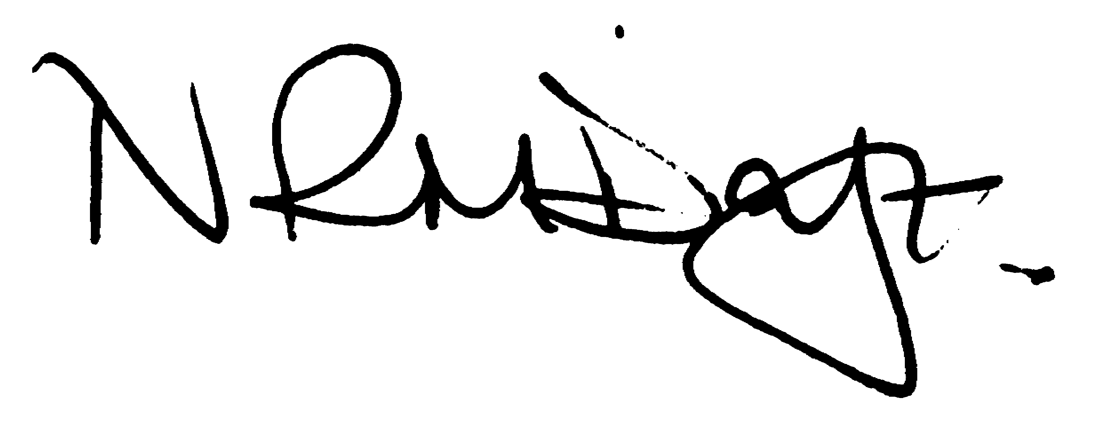

Nikki Daft – Parish Clerk

Cllr M Griffiths to speak about the Unitary Council progress

AGENDA

APOLOGIES AND ACCEPTANCE OF APOLOGIES

18/102 PUBLIC QUESTIONS AND/COMMENTS

Public participation may continue until for 15 minutes after which the public must not take part at any other time during the meeting. Any member of the public can make a recording of any part of the meeting. All audible sounds to be switched to silent unless otherwise agreed at the start of the meeting.

POLICE REPORT AND NCC UPDATE

To receive a verbal report from the Police and NCC representative if in attendance

18/103 NOTIFICATION OF ANY DISCLOSABLE PECUNIARY INTERESTS OR OTHER INTERESTS
Only in respect of matters which are to be considered by members below. (Disclosures previously declared and registered need not be repeated).

- To receive declarations of interest
- Councillors to declare any personal interest in any items on the agenda
- Councillors to declare any personal and/or prejudicial interest in any items on the agenda and to inform the Chairman if they wish to speak on the matter during public participation

18/104 MINUTES - To approve the minutes of the meetings held on 30th January 2019 as a true record.

18/105 RESOLUTIONS AND ACTIONS - MATTERS FROM PREVIOUS MINUTES

Planning responses – completed Cherry Tree quotes and BCW – Agenda Book cemetery course
Circus details Quotes re grave mounds - Agenda Cemetery sunked grave
Highways section 136 completed

18/106 FINANCIAL/POLICIES

- To Approve Payments for February 2019 details sent to councillors via email (Clerk)
- To receive information regarding the current financial statement – reconciliation statement sent to councillors via email (Clerk)
- To agree the authorisation of the bacs payments

18/107 RECREATION GROUNDS

- To receive and agree the reports/repairs/damage to the recreation grounds (JD)
- To discuss the making of a byelaw for the open spaces in Irchester

18/108 HIGHWAYS

- To agree any items that need to be added to the next agenda

18/109 LITTLE IRCHESTER/KNUSTON - To agree the Highway Warden report. Matters arising will be added to the next agenda.

18/110 PLANNING - To discuss any planning issues

- WP/19/00045/FUL Single storey rear extension to replace conservatory and conversion of garage to bedroom including the removal of garage door and replacement with window and brick infilling. 8 Redwood Close, Irchester
- WP/19/00063/FUL Proposal: First floor side extension, with new brick facing to side wall below Location: 11 Redwood Close, Irchester

18/111 CEMETERY/WAR MEMORIAL/GARDENS

- To note the report from the Cemetery Working Party and decide if any item needs to be added to the next agenda
- To discuss Councillors attending the Cemetery Management Course

18/112 COMMUNITY/CONSULTATIONS EVENTS

- To receive a report from the Village Voice Working Party and decide if any item needs to be added to the next agenda
- To receive details regarding the progress of the library
- To discuss the recycling crisp packet programme

18/113 CORRESPONDENCE To consider information received from incoming correspondence and decide on agenda items for the next meeting.

18/114 EXCLUSIVE TO PUBLIC AND PRESS

18/115 STAFFING WORKING PARTY RECOMMENDATIONS

To discuss Staff Pension and payment of Holiday Pay as recommended by the Staffing Working Party

