IRCHESTER PARISH COUNCIL

Minutes of the Ordinary Meeting of the Parish Council held on Wednesday 30th March 2022 at the Village Hall, School Road at 7.15p.m.

Members Present:
P Armstrong – In the Chair

Councillors
P Smith K Watts D Shroll V Wilkinson L Brown JP Carr N Gibbons

The meeting started at 7.15pm. there were 5 members of the public present.

Apologies - Agreed and Accepted from Cllr T Maguire, J Dunkley & M May

21/94 Public participation/Police Report/North Northants Council

Public - Query was asked as to why the pc was not flying the Ukranian Flag. Advice had been sought and it was stated that to fly another countries flag was making a political statement and it was not advisable to fly one on a war memorial. It was agreed to print flags and add them to the notice boards.

Query was raised regarding lighting upgrades however this was in the area where NNC are responsible for the lighting.

NNC Councillors and highways had visited the village and looked at several areas regarding highways matters. It was stated that there is currently a consultation on Green waste if councillors wished to make comments.

21/95 Declaration of Interest
Cllrs PA/LB agenda item 21/105
Cllrs PA/NG/JPC agenda item 21/102 Queens Platinum Jubilee

21/96 Co-option of Councillor

Mr K Clarke was Co-opted as Councillor for the Irchester Ward. The Declaration of Acceptance of Office was signed.

21/97 Minutes

- The minutes from 23rd February 2022 were agreed as a true record to be signed by the Chair.

21/98 Financial Matters

- Payments – Resolved: That the payments of £7,953.59 for March were approved
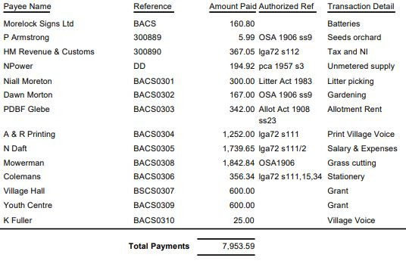

- The Current financial statement after the payments being £179,554.28
- RESOLVED that Cllrs JP Carr & L Brown to authorise the bacs payments for March 2022

21/99 Cemetery/War Memorial
- There had been a few interments in the cemetery. There had been an issue with a funeral director regarding alteration of forms and costs and also leaving spoil in the cemetery which they refused to remove. It was RESOLVED to write to them advising that they would not be allowed in the cemetery in the future. It was stated that some plot holders had had flowers and memorabilia removed from graves.
- Suggestion was made to plant a memorial tree for all those who have died from the recent pandemic. A memorial seat was also discussed and it was RESOLVED to purchase a seat and install it in the centre of the village at Peartree Corner.

21/100 Highways

- An Assignment and Agreement form had been received regarding the bus shelter claim in January 2021 regarding an uninsured driver. It was agreed not to sign the forms until further information had been received from Zurich.
- The preliminary consultation annual parking review was discussed.
- The Asset Mapping Working Party had met and highlighted and assets and services provided by NNC had been recorded. Details sent to councillors with no further additions.
- It was stated that there had been a number of cars parked on Gipsy Lane from the country park whilst repairs had taken place with the car park and that there seemed to be more litter in Little Irchester on Saturday mornings.

.21/101 Play Areas

No problems recorded – new rota to be organised

21/102 Community Projects

- Orchard – seed balls and meadow seeds planted. Sweet Almond tree had been offered however this would grow too tall for the area. Young volunteer attends every week and looks after the area. Would like to install 3 raised beds for herbs and flowers to encourage bees etc. Wood has been donated for the planters. Someone had fly tipped some concrete and bricks in front of the dog bin area.
- Library – The two large and the scaffolding has been removed. The outside wall and block paving had also been repaired
- A steering group had been set up of community volunteers to organise a Big Lunch on Sunday 4th June to celebrate the Queens Platinum Jubilee. Request had been made from members of the steering group for a contribution towards equipment for the day. RESOLVED to accept the quotation of £210.83 plus VAT. RESOLVED that the recreation ground could be used for parking and that the council would write to the Co-op for a community donation.
- RESOLVED that the WI can decorate both War Memorials with poppies again in November following the guidelines from the previous year. Little Irchester War Memorial would need to be checked daily by the Lt Irchester Councillors regarding safety etc.
- It was stated that the planter in the centre of the village will be filled in April. RESOLVED to allocate £150 towards plants.

21/103 Planning

NW/22/00150/FUL – Demolition of existing dwelling, construction of new 2 bed single storey dwelling with conservatory – 18 Caravan Site Gipsy Lane – although the building already had previous planning for a dwelling concern was raised regarding the policy for development for a travellers site
22/00297/LAPNEW- Licence: Premises - Little Devil Distillery Ltd Address: 51 Norman Way, Irchester - Sale of Alcohol Alcohol consumed off premises Saturday 10:00 - 16:00 Monday to Friday 08:00 - 20:00 - The opening hours of the premises Saturday 10:00 - 16:00 Monday to Friday 08:00 - 20:00 – concern was raised regarding the size of the still, the sale of alcohol from the premises and the number of vehicles visiting a residential site.

21/104 Exclusive to Public and Press

RESOLVED: That pursuant to the Public Bodies (Admission to Meetings) Act 1960, the public and press is excluded from the meeting for the item of business on the grounds that publicity would be prejudicial to the public interest by reason of the confidential nature of the business to be discussed.

21/105 Village Hall Car Park

RESOLVED to ask the resident who has a lease to drive through the car park for a contribution towards the resurfacing of the car park.

Meeting closed at 9.00 pm

Chair

