IRCHESTER PARISH COUNCIL

Minutes of the Annual and Ordinary Meeting of the Parish Council held on Wednesday 29th May 2024 at the Village Hall, School Road at 7.15p.m.

Members Present:
K Watts – In the Chair

Councillors
M May JP Carr S East D Shroll J Dunkley B Leeson
A Hurley

The meeting started at 7.15pm. there were 4 members of the public present

Apologies - Received from Cllrs P Armstrong, P Smith & G Brotherston

24/1 Election of Chair

Nominations and Seconders for the Chair were received for Cllr Armstrong and Cllrs Watts.
RESOLVED Cllr Watts be elected as Chair for the forth coming year. The declaration of office paperwork was signed and witnessed by the Clerk

The Councillors agreed for PCSO to speak regarding the crime stats that were previously sent to them. It was also stated that several dates for the police surgery in the library were to be published

24/2 Declaration of Interest

Cllr Watts other interest planning application for Grange Way

24/3 Appointment of Members to the following specific areas of interest

- Vice Chair – Nominations and Seconders were received for Cllr Armstrong, Cllr Hurley & Cllr Smith – RESOLVED Cllr Hurley voted in as Vice Chair
- Internal accounts Controller – Cllr M May
- Footpaths – Cllr A Hurley
- Highway Wardens Irchester, Little Irchester and Knuston – J Dunkley
- H & S Representative – J Dunkley

24/4 Appointment of Advisory Groups/Working Parties – Chair and Vice Chair being ex-officios
Groups below to be set up as and when required:

Recreation Cemetery Highways and Lighting Orchard

The following established Working Parties

- Finance, Staff & Policies – Members being Chair, Vice Chair, Cllrs JP Carr, D Shroll, S East & B Leeson - role to advise council on staffing issues, policies new and updates, monitor finances throughout the year and look at budgets prior to full council.
- Planning – Members being Chair, Vice Chair, Cllrs JP Carr, & J Dunkley – 2 vacancies – role to look at the planning applications and advise council on planning policies.
- Emergency planning/flooding – Members being Chair, Vice Chair & Cllrs P Smith – 2 vacancies – role to update emergency plans as and when required.
- Community Projects – Members being Chair, Vice Chair, Cllrs Carr, ~P Smith & B Leeson – role to recommend, organise and cost projects.
- Village Magazine – Members being Chair, Vice Chair Cllr Armstrong & 1 MOP – 2 vacancies – role to produce and distribute the Parish Magazine
New Working Parties

- Youth Council – role to investigate and set up a Youth Council – Chair, Vice Chair Cllrs G Brotherston & B Leeson
- AI and Technology – role to investigate how AI and Technology can help the council in the future and make better communication with residents – Chair, Vice Chair Cllrs B Leeson & JP Carr

24/5 Appointment of Representatives on Outside Bodies

RESOLVED representatives on Outside Bodies being:

a) Irchester Sports Association (2) Cllr P Smith & K Watts b) Village Hall Committee – Cllr A Hurley
c) Youth Centre Management Committee – Cllr K Watts d) Allotment Association – Cllr Watts
e) Bowling Club Committee – Cllr P Armstrong f) Library – Cllrs K Watts/A Hurley

24/6 Dates of Council Meetings 2024/25

RESOLVED the dates for council meetings throughout 2024/25 being

26th June 2024 28th August 2024
25th September 2024 30th October 2024
27th November 2024 29th January 2025
26th February 2025 26th March 2025
30th April 2025 Election year 14th May 2025

Minutes of the Ordinary Meeting of the Parish Council

24/7 Public questions, Police Report and NNC update

Public: Concern was raised regarding the cars being parked on the footpaths making it difficult for wheelchair and mobility scooter access. PCSO D Fenner had been informed however was unable to enforce removal. Cllr Carr to notify the NNC enforcement team.

It was noted that Hilton Hall in Little Irchester was being neglected and needed vegetation removed and repairs.

It was noted that the Staff Working Party were given delegated powers to appoint new members of staff.

NNC Update – Leaders report sent to councillors

24/8 Minutes

- RESOLVED to approve the minutes held on 24th April 2024 and signed by the Chair as a true record. It was requested that draft minutes be sent to councillors within 10 working days of the meeting.

24/9 Co-option

RESOLVED to accept A Howden as a co-opted councillor. Declaration of acceptance of office was signed. It was requested that reasons for councillor resignations be sent to councillors in the future. It was stated that Cllr Clarke had reached the 6 month rule and was therefore now disqualified from being a councillor creating a further vacancy. NNC to be informed.

24/10 Financial Matters

- Payments – Resolved: That the payments of £12,808.20 for May 2024 were approved
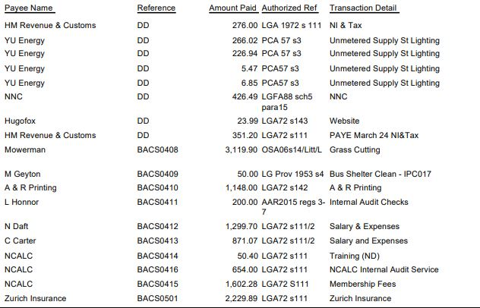
- The Current financial statement after the payments and before DD’s being £265,397.44
- RESOLVED that Cllrs Carr and Cllr Armstrong to authorise the bacs payments for May 2024
- RESOLVED to accept Cllrs Hurley, East & Leeson on the bank mandate
- RESOLVED to accept the Financial Risk Assessment, Standing Orders and Financial Regulations with the recommended changes.

24/11 Recreation Ground

No issues arising. Skate Park Austin Close repairs to be carried out within the next couple of weeks.
Little Irchester – a member of the public raised concerns regarding the post in the play area however there was not a problem with it remaining until a new piece of play equipment was installed.

24/12 Highways

- No new issues reported however it was noted that NNC would not be cutting the grass verges for 2 months. Other complaints had been received regarding wheelchair and mobility scooter access from Irchester to Wellingborough past the Gipsy Camp to the roundabout and also along Knuston Hill. This had been reported to NNC highways.
- Discussion took place regarding residents purchasing a new memorial bench for the corner of Bradshaw Way. It was stated that the current bench was also donated however Cllr Howden would look into costs and other possible positioning. It was also noted that other suggestions for a councillor memorial could be discussed with the Sports Association.
- RESOLVED to accept the quotation to repair the bench next to the water tower in Farndish Road

24/13 Cemetery/War Memorial

- There were a few ashes and interments booked in the cemetery for June. Question was raised regarding the anticipated time left for interments which is estimated at approximately 20 years.

24/14 Planning

- NW/24/00255/FUL – Demolition of garage and store and erect new ones – 20 Roman Way – No comments
- NW/24/00244/LBC – Repointing Blacksmiths Cottage – 57 High Street – No comments
- NW/24/00174/PAS - Prior approval proposed for installation of a PV array on the roof of an existing B1(c), B2 and B8 class building. Location: 15 - 23 Claudius Way Irchester – No comments
- NW/24/00268/FUL – Provision of new air source heat pump – 4 Grange Way – Comments to follow

24/15 Correspondence

A letter had been received from a resident asking for more bins in Woodlands Road area

Meeting closed at 9.00pm Chair

