
The Parish Council of Irchester
Clerk  Nikki Daft PSLCC  45 Park Road  Irthlingborough  Northants  NN9 5PW |  | Telephone 01933 384180  irchesterpc@gmail.com  www.hugofox.com/community/irchester-parish-council-13388/about-us

Dear Councillor 16th May 2018

You are hereby summoned to attend the Annual meeting of Irchester Parish Council followed by the ordinary meeting of the Parish Council to be held at Village Hall, School Lane, Irchester on Wednesday 23rd May 2018 at 7.15p.m.

Yours faithfully
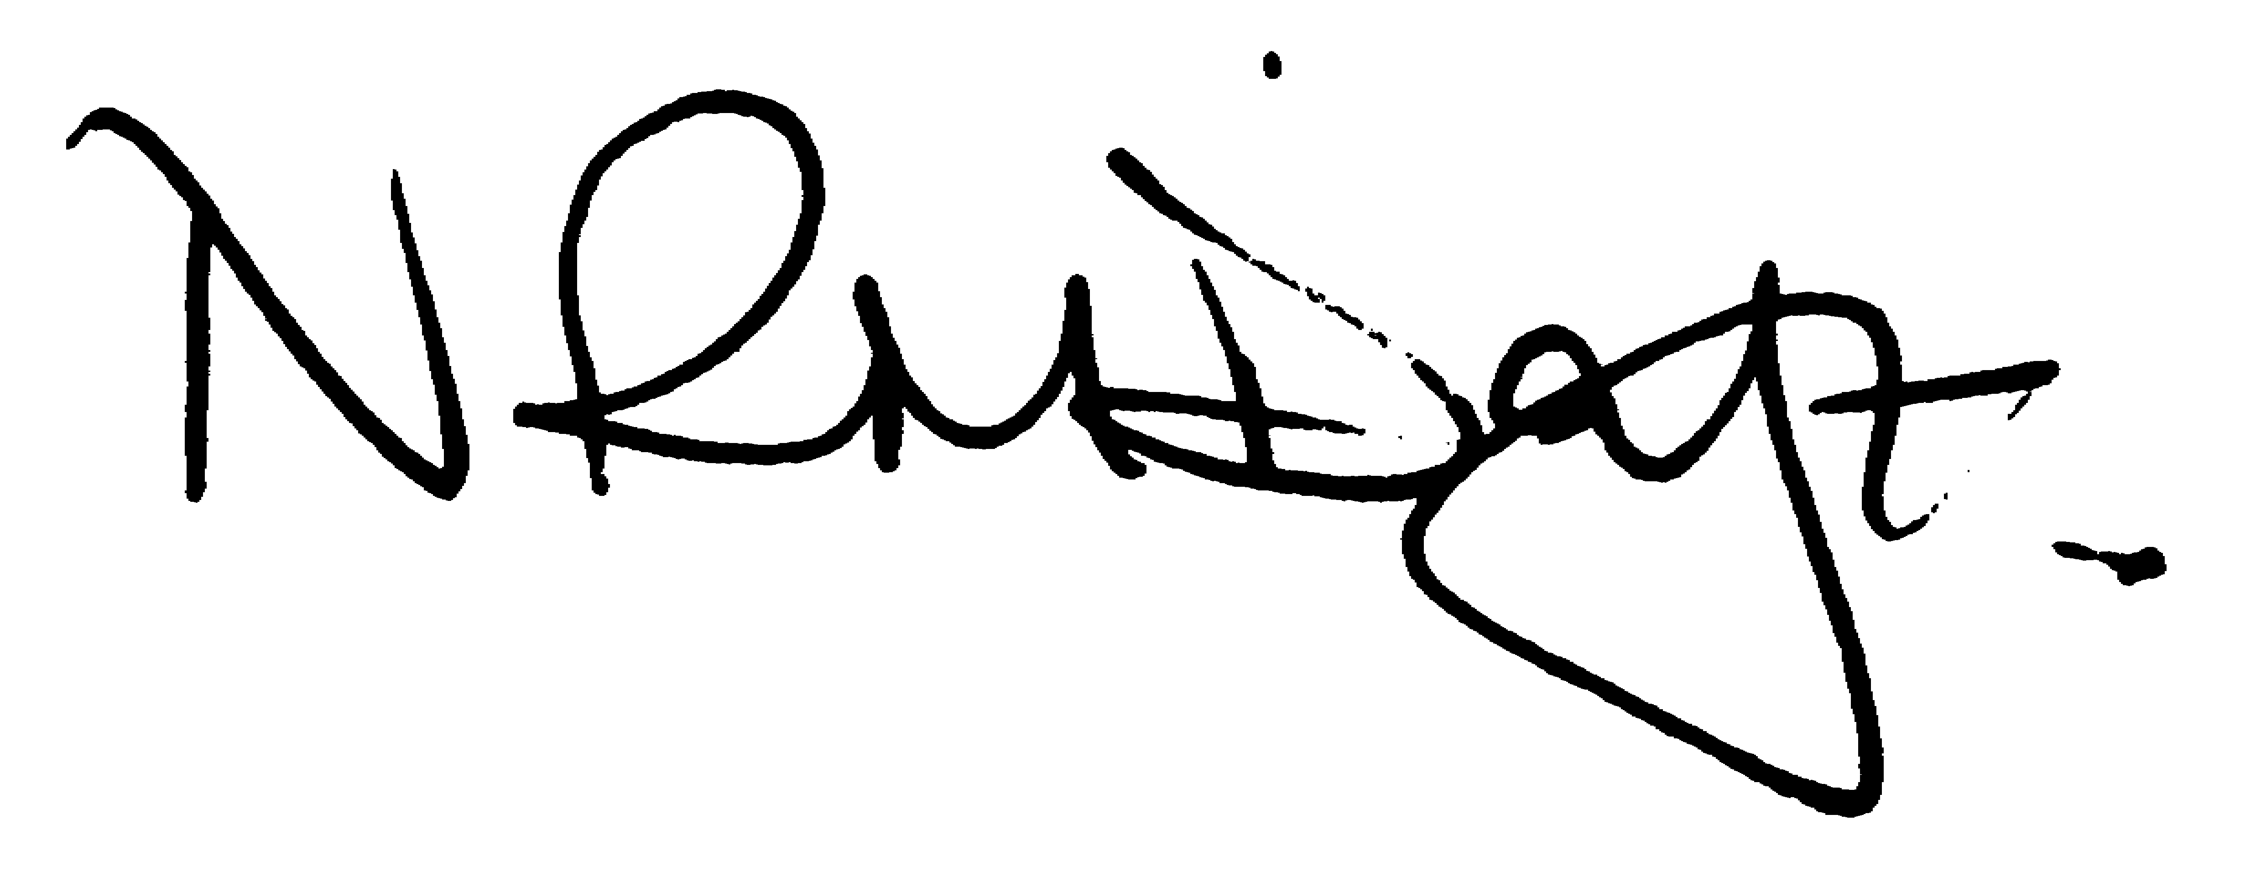

Nikki Daft – Parish Clerk

AGENDA

APOLOGIES AND ACCEPTANCE OF APOLOGIES

18/1 CHAIRMAN ELECTION AND ACCEPTANCE OF OFFICE

- To receive nominations and elect a Chair for the Parish Council for the ensuing year. Declaration of acceptance of office to be completed.

18/2 NOTIFICATION OF ANY DISCLOSABLE PECUNIARY INTERESTS OR OTHER INTERESTS
Only in respect of matters which are to be considered by members below. (Disclosures previously declared and registered need not be repeated).

- To receive declarations of interest
- Councillors to declare any personal interest in any items on the agenda
- Councillors to declare any personal and/or prejudicial interest in any items on the agenda and to inform the Chairman if they wish to speak on the matter during public participation

18/3 APPOINTMENTS OF MEMBERS to the following specific areas of interest:

a) Vice Chair b) Internal Accounts Controller and Digital Overseer
c) Footpaths d) Highway Wardens for Irchester, Little Irchester and Knuston
e) H & S Representative

18/4 APPOINTMENT OF ADVISORY GROUPS

- Finance
- Recreation
- Cemetery
- Planning
g) Emergency planning/flooding

18/5 APPOINTMENT OF REPRESENTATIVES ON OUTSIDE BODIES

To appoint representatives on Outside Bodies for the following:

a) Irchester Sports Association (2) b) Village Hall Committee
c) Youth Centre Management Committee d) Allotment Association
e) Bowling Club Committee

18/6 DATES OF COUNCIL MEETINGS 2018/19

To approve the dates and venues for meetings throughout 2017/18

27th June 2018 30th January 2019
29th August 2018 27th February 2019
26th September 2018 27th March 2019
31st October 2018 24th April 2019
28th November 2018 May 2019 meeting to be agreed as election year

To commence the Ordinary Meeting of Irchester Parish Council

18/7 MINUTES

a) To approve the minutes of the meeting held on 25th April 2018 as a true record

18/8 PUBLIC QUESTIONS, POLICE REPORT AND NCC UPDATE

Public participation may continue until for 15 minutes after which the public must not take part at any other time during the meeting. Request should be made to the Chair if any member of the public wishes to make a recording of any part of the meeting. All audible sounds to be switched to silent unless otherwise agreed at the start of the meeting. A report only can also be given by the Police and NCC representatives

18/9 RESOLUTIONS AND ACTIONS - MATTERS FROM PREVIOUS MINUTES

- Wet pore quotes
- Letter sent regarding boundary fence
- Report to Street Doctor
- Letters to Secretary of State, MP and NCC Councillor re library building

18/10 FINANCIAL/POLICIES

- To Approve Payments for May 2018 (Clerk)
- To receive information regarding the current financial statement (Clerk)
- To agree the authorisation of the bacs payments
- To agree the Councils Insurance for 2018/19
- To review the Standing Orders, Financial Regs, Risk Assessment and Internal Audit Controls for 2018/19
- To adopt the GDPR policies, previously circulated to councillors
- To agree that Northants CALC be the Data Control Officer for the GDPR for the forth coming year FOC
- To agree the Annual Governance for the External Auditor and receive the Internal Auditors Report for the accounts ending 2017/18
- To discuss training for the Clerk for Quotes, Contracts and Tendering In October over 3 sessions at a cost of £90.00 plus VAT

18/11 RECREATION GROUNDS

- To receive and agree the reports/repairs/damage to the recreation grounds (JD)
- To discuss the quotations for the wet pore repair

18/12 HIGHWAYS

- To agree the Highway Warden report, previously circulated. Matters arising will be added to the next agenda
- To discuss the cost of the light installed on the Working Mens Club and agree an annual cost payable to them.
- To discuss the cost of the light to repair in the alleyway off Alfred Street
- To discuss the light in Station Road and to decide if the pc wish to repair it

18/13 LITTLE IRCHESTER/KNUSTON

- To agree the Highway Warden report

18/14 PLANNING

- WP/18/00242/FUL - The construction of a canopy stretching over the bay window and front door. 17 Gipsy Lane, Irchester

18/15 NEIGHBOURHOOD PLAN(NHP)

- To receive an update on the progress of the NHP

18/16 CEMETERY/WAR MEMORIAL

- To receive the cemetery report and decide if details should be added to the next agenda
- To discuss 2 graves which have installed stone and plastic edging to the plots and decide what action needs to be taken

18/17 CORRESPONDENCE

To consider information received from incoming correspondence and decide on agenda items for the next meeting.

- To agree the use of the recreation ground for an overspill car park for the Romans on 9th June and the Gala on 17th June

18/18 EXCLUSIVE TO PUBLIC AND PRESS

18/19 COMMUNITY ASSETS

- To discuss updates and issues regarding the Parish councils Community Assets namely
- Library
- Hilton Hall
- Parsons Hall

