IRCHESTER PARISH COUNCIL

Minutes of the Meeting of the Parish Council held on Wednesday 27th August 2014 at Village Hall, School Road, Irchester at 7.15p.m.

Members Present:
P Armstrong – In the Chair

Councillors
Mrs A May I French P Smith D Shroll
K Clements D May J Gibson L Brown

The meeting started at 7.15pm. There were 5 members of the public present.

Apologies - Resolved to receive and accept apologies from Cllrs T Maguire, M May, J Dunkley& C Painter

14/32 DPI's

None Declared

14/33 Minutes

RESOLVED that the minutes of the meeting held on 25th June and 21st July 2014 were agreed as a true records.

14/34 Public participation, police reports and NCC updates

The Chair stated that public participation may continue for 15 minutes after which the public must not take part at any other time during the meeting. Request should be made to the Chair if any member of the public wishes to make a recording of any part of the meeting. All audible sounds to be switched to silent unless otherwise agreed at the start of the meeting. A report only can also be given by the Police and NCC representatives

Public comments –

Posts near Parsons Hall missing from the grass. It was stated that there were cables under the grass so it was felt these posts should not be replaced. Some people still park on the grass verge on occasion though so the Youth Centre will monitor this.

Post also missing in the High Street to Station Road

It was noted that there was a gap between the posts on Recreation Ground so that a Trotting Pony could get through

Chair thanked the public for their comments.

Police:

14/35 Actions/Matters from previous minutes

New Solicitor appointed CJ Spoor from Church Street, Rushden in order to follow up the registration of the Bowls Club.
The solicitor would also be happy to register all other land belonging to the council.

Flyposting not as bad as previously reported

Trees cut back

Moles eliminated.

It was noted that there had been a lot of litter left near the village hall in recent weeks. Situation to be monitored.

14/36 Financial Matters

a) Approval of Payments – Resolved: That the payments £5,831.56 for August 2014 be approved and also the computer at a cost of £534.59 from August

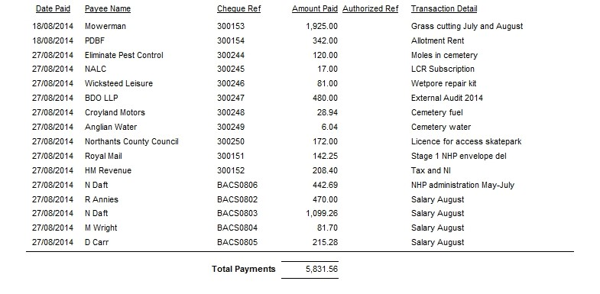

b) The bank statement of £157,394.14 was noted as being available after current payments made.
c) RESOLVED that Cllr Miss L Brown and I French authorise the bacs payments for August
d) The external audit annual return had been received with no matters arising.
e) The date of the Finance meeting was agreed as 16th September 2014
f) RESOLVED to adopt the SO with the change of wording for 3l recording meetings

14/37 Recreation Grounds

a) There had been problems with the seats on one of the exercise equipment. This had been mended in the past however the seats could not be purchased separately. It was RESOLVED to have the piece of equipment removed.
b) Skatepark - the order had been placed with HAGS and work was scheduled to start in October. The Chair and Clerk attended the open day at Knuston Hall and sold tickets for the raffle. The first prize was £100 cash, donated by The Mowerman with 2nd and 3rd prizes being a family day at Santa Pod Flame and Thunder and Outdoor Lighting had donated Waitrose vouchers to the value of £100.00 Several other raffle prizes had been donated. A disco was being arranged for the end of September and also a further car wash.
c) S106 - it was agreed to hold a meeting to discuss possible projects.
d) It was agreed that Pindar Circus use the Recreation Ground from Monday 20th October to Wednesday 22nd October and at a cost of £150.00
e) Quotations had been received for the replacement of 17sqm of wet pore near to the slide that needed to be repaired. It was RESOLVED to accept the quotation of £1095.00 plus VAT
f) The football rota for Saturday mornings was agreed with councillors carrying out risk assessments of the ground.

14/38 Highways –

a) The Highway Warden report was noted placed on the council’s website.
b) RESOLVED to replace the litter bin outside the Co-op with a larger covered one from Glasdon at a cost of no more than £360.00 fitted
c) Dog fouling - the dog bones received from the police and Dog warden were distributed on the Borough Councillors litter pick day on 12th July
d) Dog bins were requested for alleyway near junction of School Lane although there is currently one in the alleyway, half way up Woodlands Road and Arkwright Road Warren Close alleyway. It was felt that no further bins were required and a map of bin locations will be included in the next Village Voice.
e) DPPO signs - still waiting for the design. Agreed to purchase signs 7 at £49.00 each plus delivery
f) A letter had been received from Anglian Water stating that they felt that the problem had been resolved. SO were suspended in order for a member of the public to speak stating that he had contacted the MP regarding the problem. SO Resumed
g) RESOLVED to purchase flags for EU, Christmas/New Year, Commonwealth, Northants Flag, at a cost of no more than £5.00each and others as required
h) RESOLVED to purchase a further 12 Neighbourhood Watch Signs at a cost of £17.00 each
i) RESOLVED to purchase 5 Anti bullying signs at a cost of £10.00 each
j) Discussions took place regarding the upgrading of lights in the village and if was stated that the lights on Chester Road could be reduced and the light in the alleyway near Ash Close would need replacing however this belongs to NCC. Agreed to get a quotation for the Chester Road lights to remove the bottom lights. It was agreed to write to Network Rail regarding the damage lamp in Chester Road.

14/39 Little Irchester/Knuston

a) The Highway Warden report was noted and placed on the council’s website.

14/40 Planning - The following applications had been received:

- A Neighbourhood Plan update was received There was concern regarding the Chester Road appeal.
Standing Orders were suspended so that the chair of the NHP could explain. The appeal for Earls Barton had been called in by the secretary of state so that they he could make a decision. The Chester Road appeal will be heard on 30th September. Anyone can ask to have an appeal called in but they would need to have information to support it. WBC planning officers are looking at this process to see if it was feasible. WBC are also suspending all planning applications outside the village policy line until the Chester Road appeal has been finalised as they have a 5 year supply of land. Standing Orders resumed. Chair received a telephone call from land owner next to Austin Close play area regarding potential development of his land. There are other land owners of the old allotments also and they have been advised to contact the consultant of the NHP.
- WP/14/00516/FUL- 2 storey front dwelling – 26 Roman Way – No comment
- WP/14/00514/OUT – one two storey house – 153 Bradshaw Way – support application no comments
- WP/14/00518/FUL – Side extension – 18 Beech Crescent – no comments
- WP/14/00129/FUL/ WP/14/00555/FUL – rear and side extension resubmission – 59 Woodlands no further comment
- WP/14/00360/FUL – Front read and side extension – 61 Gipsy Lane – site viewing arranged
- Irchester Primary School – Installation of mobile classroom – no comments

14/41 Community Assets

Discussion took place regarding the unauthorised parking at Parsons Hall. A notice or gate was requested in order to try and alleviate the problem. The authorisation to allow parking however would need to be policed so it was agreed to monitor the situation further.

14/42 Remembrance Day

It was agreed that the pc would support the Remembrance Day Service and allocate costs towards Irchester service and £50.00 towards the Little Irchester service.

14/43 Correspondence

- The flood meeting was agreed for Tuesday 7th October 2014 at the Village Hall for 7pm
- It was agreed that Pete Smith attend the NCALC AGM on 18th October and be the voting delegate
- WBC had sent information regarding the polling stations of which the pc did not want to make changes
- Letter from resident who had damaged glasses whilst delivering the village voice asking for reimbursement. This to be added to the next agenda.
- Police would like the pc to support the recruitment of Parish Constables.

There being no further business the meeting closed at 9.20 pm Chair

