IRCHESTER PARISH COUNCIL

Minutes of the Ordinary Meeting of the Parish Council held on Wednesday 30th August 2023 at the Village Hall, School Road at 7.15p.m.

Members Present:
P Armstrong– In the Chair

Councillors
P Smith L Brown JP Carr T Maguire K Watts A Hurley
C Ashford D Shroll K Clark M May B Leeson

The meeting started at 7.15pm. There were 3 members of the public present.

The Chair welcomed the newly elected councillors to the meeting.

Apologies - Agreed and Accepted from Cllrs J Dunkley, S East & S Bridge

23/26 Public Questions, Police Report and NNC Update

Public – Asked if a ‘Day for Celebration’ could be added to a future agenda
Query Tree maintenance along Wollaston Road – NNC Cllr stated that there was, as yet, no definitive answer regarding the maintenance and pollarding of NNC owned trees.
Query raised re Entrance being used along Gipsy Lane to the solar farm and also the no right turn from the site which has been directed to NNC building control.
Query re agenda items – members of the public can ask for items to be added to the agenda however the queries may be sign posted elsewhere if not within the pc powers.

There was no Police report available

NNC report – Leaders update previously sent to councillors. The 3 NNC Ward Cllrs had met with the highways representatives to discuss issues within the village many of which were being addressed.

23/27 Notification of Any Interests

Cllr Leeson minute ref 23/31 (d) and minute ref 23/33 (b)

23/28 Minutes

The minutes from 28th June 2023 meeting were agreed as a true record and signed by the Chair.

23/29 Financial Matters

- Payments – Resolved: That the payments for £8336.12 for July and £5034.46 August 2023 were approved. Direct Debits for June & July being NNC £1237.50 & Bank charges £27.15
July Payments
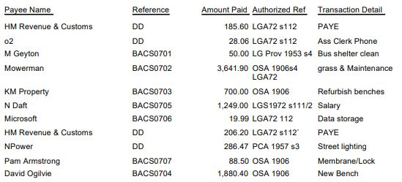

£8336.12

August Payments
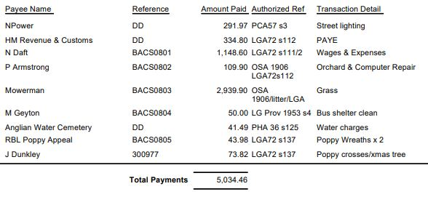
Late payment for PKF Littlejohn for £420.00 plus VAT £84.00 totally £504.00. It was also stated that the external audit report had been received with no matters arising.

- The Current financial statement after the payments being £239,225.72
- RESOLVED that Cllrs P Smith & P Armstrong to authorise the bacs payments for August 2023
- The request for a grant from the Village Hall Committee was no longer required.

23/30 Cemetery/War Memorial

- It was stated that several interments had taken place throughout July and August.
- It was stated that the grass spoil removal will take place within the next few months however concern was raised that this would be an on going issue.

23/31 Highways

- Concern was raised regarding the state of the roads with pot holes not being repaired. It was agreed by NNC, at a previous meeting held with them, that some pot holes would be repaired in August. However query was raised as to why only part areas were repaired and not others. No further updates were forthcoming.
- Problems were being experience with parking in Little Irchester regarding visitors to the Country Park. A proposal has been made to extend the yellow lines in Daniels Road/Newtown Road but parking still remains a problem.
- The quotation for weed spraying several alleyways was discussed however if was agreed to ask for a requote to remove weeds, dispose of waste and weed spray
- Discussion took place regarding the proposal for Speed restriction reduction to 40mph in Gipsy Lane outside of the country park. Councillors were concerned that drivers would have 3 speed limits in close proximity and proposed that the 40mph be extended in both directions from the village to Little Irchester. Cllr Maguire asked for his vote of objection to be recorded.

23/32 Play Areas

- The request for a further seat on the Recreation Ground was discussed and it was agreed not to place a seat in that area at this moment in time. The Recreation Working Party to arrange a meeting to discuss potential improvements.
- The roundabout in Daniels Road play area had been removed due to safety issues.

23/33 Community

Discussion took place regarding the Remembrance Day Service and it was agreed to set up a Working Party with the same format for both villages as in previous years.

Cllr Leeson left the meeting

Discussion took place regarding holding a meeting with Parsons Hall Committee in respect of the ongoing relationship with the pc, its representative and why the councillors were not advised in advance of tree works. Dates for a meeting to be agreed

Cllr Clarke left the meeting

Cllr Leeson rejoined the meeting

23/34 Correspondence

- The library had been accepted and was again registered as a community asset

23/35 Exclusive to Public and Press

RESOLVED: That pursuant to the Public Bodies (Admission to Meetings) Act 1960, the public and press is excluded from the meeting for the item of business on the grounds that publicity would be prejudicial to the public interest by reason of the confidential nature of the business to be discussed.

23/36 Promotion Agreement

Further advice had been received regarding the promotion agreement where it was stated that the pc should be employing a chartered surveyor to represent the council. Request had been sent to 4 organisation 1 of which refused due to working for a local land owner, 1 did not respond and 2 had given quotations. It was agreed to work with Eddisons in taking the promotion agreement forward.

Meeting closed at 9.05pm

Chair

These minutes are draft until agreed at the next full council meeting

