
The Parish Council of Irchester
Clerk  Nikki Daft PSLCC  45 Park Road  Irthlingborough  Northants  NN9 5PW |  | Telephone 07525909528  irchesterpc@gmail.com  www.hugofox.com/community/irchester-parish-council-13388/about-us

Dear Councillor 14th February 2022

You are hereby summoned to attend the ordinary meeting of Irchester Parish on Wednesday 23rd February 2022 at 7.15p.m.at the Village Hall, School Road, Irchester

Yours faithfully
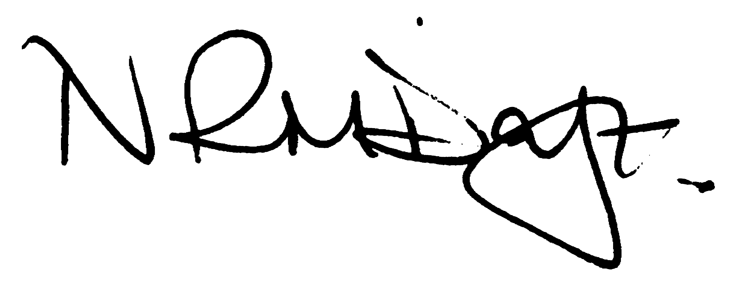

Nikki Daft – Parish Clerk

AGENDA

APOLOGIES AND ACCEPTANCE OF APOLOGIES

21/81 PUBLIC QUESTIONS, POLICE REPORT AND NNC UPDATE

Public to send questions to council prior to the meeting due to time constraints

21/82 NOTIFICATION OF ANY DISCLOSABLE PECUNIARY INTERESTS OR OTHER INTERESTS
Only in respect of matters which are to be considered by members below. (Disclosures previously declared and registered need not be repeated).

- To receive declarations of interest
- Councillors to declare any personal interest in any items on the agenda
- Councillors to declare any personal and/or prejudicial interest in any items on the agenda and to inform the Chairman if they wish to speak on the matter during public participation

21/83 MINUTES

a) To approve the minutes of the meeting held on 26th January 2022 as a true record.

21/84 FINANCIAL/POLICIES

- To Approve Payments for February 2022 (Clerk)
- To receive information regarding the current financial statement (Clerk)
- To agree the authorisation of the bacs payments

21/85 CEMETERY/WAR MEMORIAL

- To receive an update on cemetery matters

21/86 HIGHWAYS

- To receive information regarding any highways issues
- To agree the purchasing of 2 VAS batteries
- To receive an update on the Asset Management Project

21/87 PLAY AREAS

- To receive an update on the issues with the play areas
- To discuss the updated quotation for the Table Tennis tables

21/88 COMMUNITY
- To receive an update on the community orchard.
- To receive an update on the Library
- To receive an update on the Queens Platinum Jubilee Celebrations
- To agree the Feoffee Charity representative

21/89 PLANNING

- NW/22/00058/FUL - Construction of a four bedroomed detached part two part single storey house, hardstanding to front, vehicular access crossing, landscaping and boundary treatments Location: Land Between 27 And 31 Gipsy Lane
- NW/22/00066/FUL - Conversion of garage to habitable accommodation and the removal of a garage door and replacement with a window and brick infilling. Location: 4 Biscay Close Irchester
- NW/22/00067/FUL - Two storey side extension Location: 8 Orchard Place Irchester

21/90 EXCLUSIVE TO PUBLIC AND PRESS

21/91 SPORTS GROUND LEASE

To discuss the request from the Sports Association regarding renewal of the lease

21/92 VILLAGE HALL LEASE/GRANT

To discuss request from Village Hall regarding the lease/grant

21/93 ACTION FOR OLB

To delegate the plan of action for OLB to the Clerk and two Councillors

